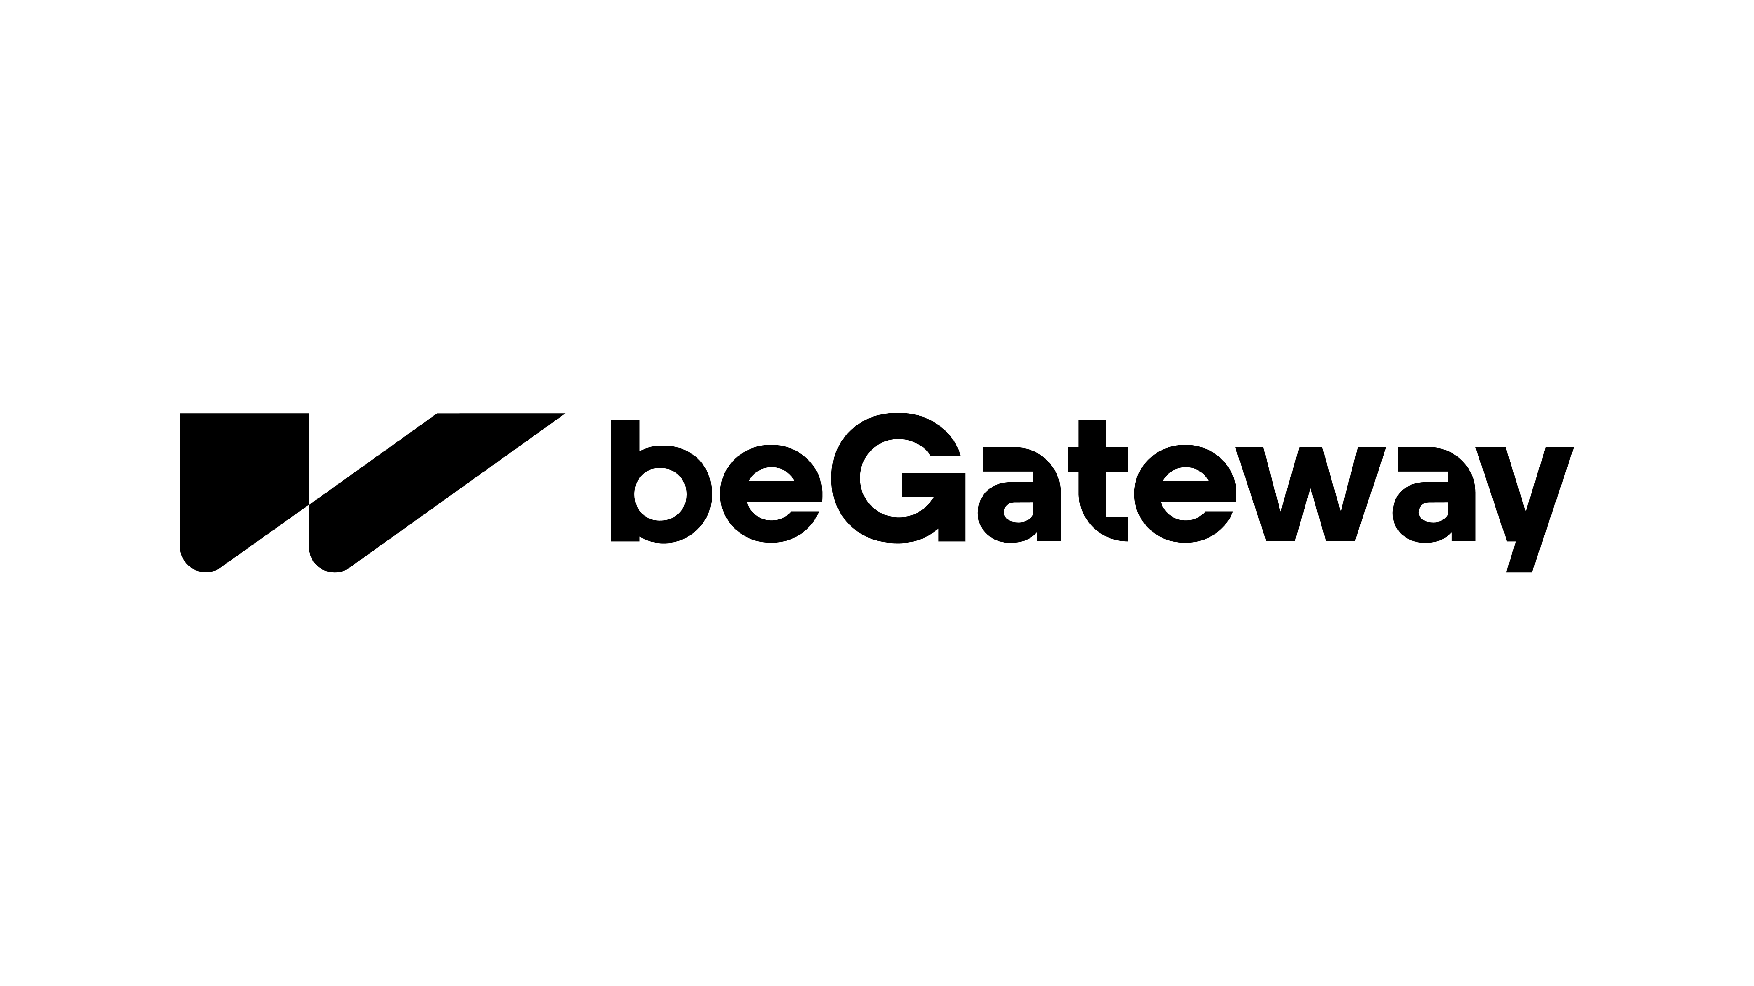

Merchant back office manual


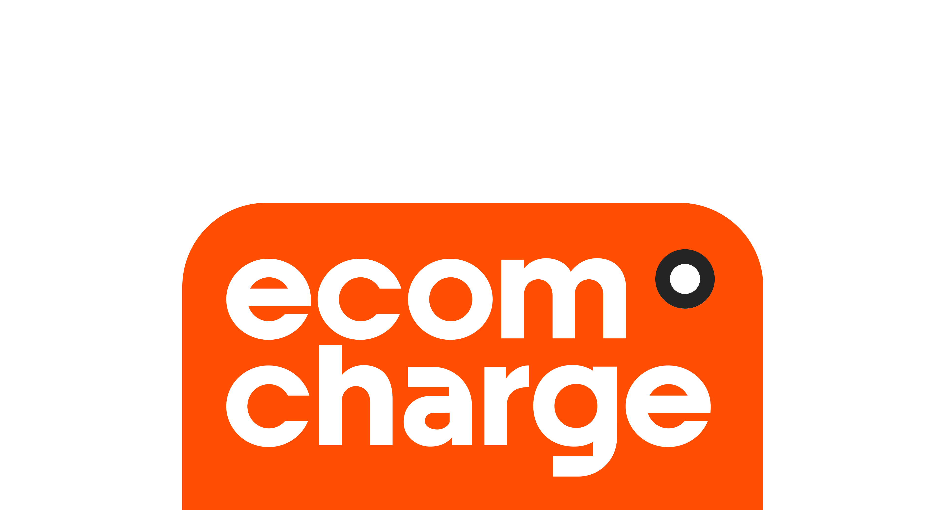

General information 4
Main interface elements 5
Before you start 8
Sign in 8
Password recovery 11
Select the interface language 12
Set a user account 12
Managing access for your staff 14
View a list of staff accounts and their statuses 14
Create an account for your staff 15
Edit and unlock a staff account 17
Delete a staff account 18
Restrict system access based on IP address 18
Shop management 20
View a list of registered shops 20
View shop details and settings 21
Get shop credentials 25
Notification settings 27
Widget customization 30
User Agreement settings 35
Setting up payment methods, subscriptions and products 37
Payment links for products 37
Create a product 38
View and edit product settings 41
Get a product payment link 43
Plans 46
Create a plan 46
Search and view plan details and settings 49
Get a plan payment link 51
Subscriptions 53
Search for a subscription 53
View subscription details, cancel a subscription 55
View subscription payments 56
Virtual payment terminal (MOTO) 56
Make a single payment or payout transaction 56
Make mass payouts 57
File for loading mass payout parameters 58
Report file 59
Google Pay 60
Apple Pay 60
Enable Apple Pay under your own certificates 60
Enable Apple Pay under your provider's certificates 61
Possible reasons for registration error 62
Transaction analysis and management 63
Find a transaction 64
View transaction summary 69
View transaction details 70
Manage black and white lists of customers' data 75
Dаshboard 76
Conversion graph 78
Decline Codes 79
Successful transactions 80
Daily history 81
Financial information 82
Payment statistics 82
Report on transactions 82
View a report 83
Export a transaction report 87
Merchant balance. Version 2 92
The merchant balance. Version 2 92

General information
The beGateway system (hereinafter referred to as the system) is a software platform designed to ensure the acceptance of online payments, their encryption, processing and routing via secure connections to banks, payment institutions and payment service providers (hereinafter referred to as acquirers). The system is PCI DSS Level 1 certified and undergoes annual certification.

The system has both an application programming interface and a user web interface. User interaction with each of the interfaces is described in separate documents. This document focuses on the interaction of merchants with the web user interface, which is a system back office.

Main interface elements
The user interface page of the system consists of the following main elements:
- Payment service provider logo.
- Area of user account management.
- Menu. It consists of tabs that relate to functions and services available to a user. See the description in the table below.
- Display area. An interface area, which is used to display or manipulate data. It may consist of the following panes:
  - header bar with the name of the page or other information;
  - search and filter pane;
  - data display pane;
  - pagination bar.
- Footer. It includes the company name of the payment service provider and its period of operation.

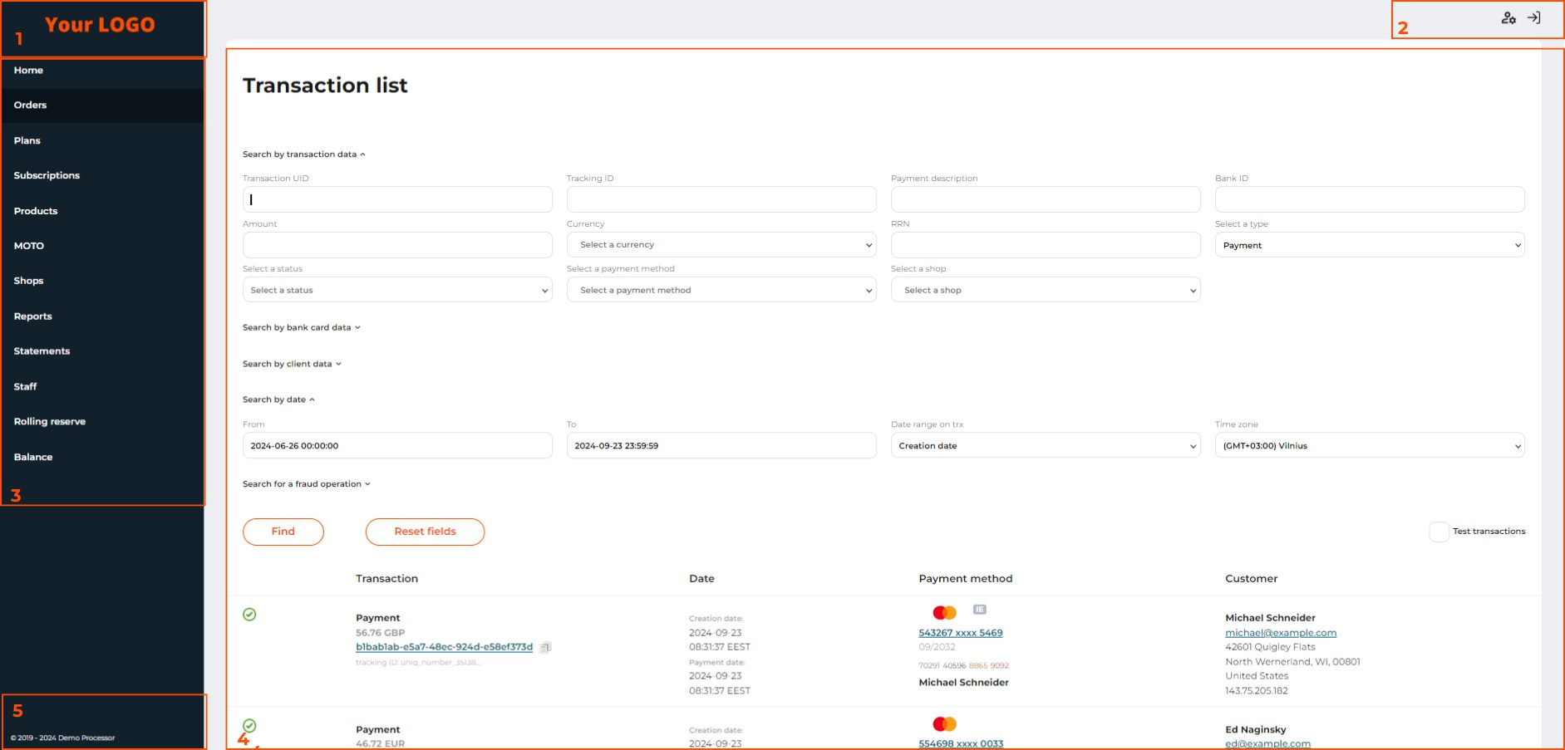
Main elements of the user web interface

Table: Features and services available on the interface tab pages

Menu tab | Actions | Notes
Dashboard | To look through a guide to connecting to the system. To view a payment statistics.

Menu tab | Actions | Notes
Orders | To view the list of payments, search for a payment, view detailed information about payments, make refunds, debits, and reversals.  To add billing details to black and white lists.
Logs | To review transaction log entries by a transaction UID and beGateway Request ID.
Plans | To create a new subscription plan for accepting recurring payments. | Might not be available depending on the provider’s settings for your account.
Subscriptions | To view customer subscriptions. | Might not be available depending on the provider’s settings for your account.
Products | To create product entries for goods and services to accept payments via payment links. | Might not be available depending on the provider’s settings for your account.
МОТО | To get access to a virtual payment terminal that allows you to accept payments and make payouts with the billing details collected by phone or email. | Might not be available depending on the provider’s settings for your account.
Shops | To view the list of your shops and detailed information on each of them.
Reports | To view or download reports based on the entered transaction search criteria.
Statements | To view financial statements for each day for each currency. | Might not be available depending on the provider’s settings for your account.
Staff | To add a staff member, make changes to the employee registration data, and change employee's permissions.

Menu tab | Actions | Notes
Rolling reserve | To view the amount of the held rolling reserve. | Might not be available depending on the provider’s settings for your account.
Apple Pay | To enable the Apple Pay service under your own or the provider’s certificates. | Might not be available depending on the provider’s settings for your account.
Balance | To view information about your balance. | Might not be available depending on the provider’s settings for your account.

Before you start
In order to get acquainted with the possibilities of the system and start accepting online payments, you, as a merchant, must be registered in the system.

After your account manager creates a merchant account and the first shop for you in the system, the system will automatically send you an invitation letter and an access link to the e-mail address specified as the merchant's contact address. Then follow the steps below:
- Follow the link in the letter.
- Provide a username (your email address) and a temporary password to log in.
- Create your permanent personal password that you will use to log in to the system. Click Change password. After entering your password, you will be automatically logged in and forwarded to the Orders page.
- Go to the Home page and study the integration instructions. After the first live transaction, you will see transaction statistics on this page.

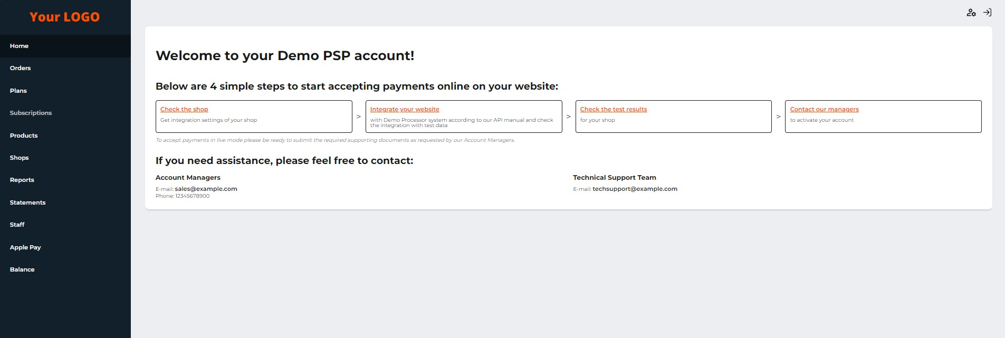

Sign in
The Home tab page

To log into the back office, follow the steps below:
- Enter your login (your email address) and permanent password that you indicated upon registering in the system.
- Click Sign in.
- If the two-factor authentication was enabled, enter 6 digits of the 2FA token.

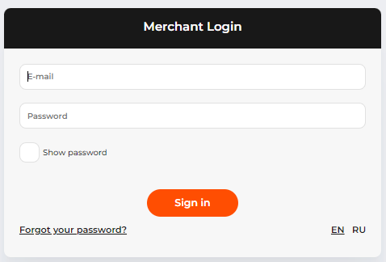
The sign-in page
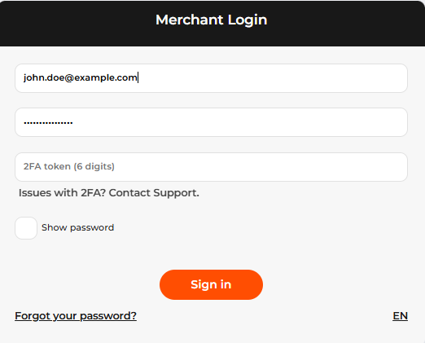
The sign-in page with the two-factor authorization

When you are entering your password, it is hidden under the password mask. To see the entered symbols, select the Show password checkbox.

 If you have entered a wrong password 5 or more times, the system blocks your account.
Contact your account manager to get your account unlocked.

Your password expires each 90 days. The system will also require a password update if you haven’t logged in for more than 30 days. The system will notify and guide you through a new password set-up.

The authorized user session lasts for 15 minutes. When the session ends, please sign in again. To close the active user session, click Sign out in the area of user account management.
Mandatory two-factor authentication
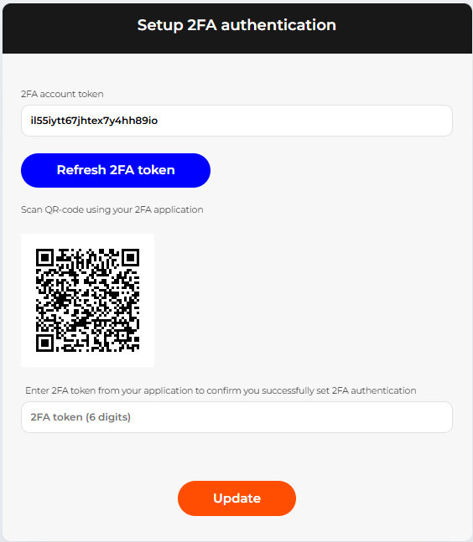

If mandatory two-factor authentication is activated for your account, once you enter the correct email and password, you will be required to add your account to the application for two-factor authentication. We recommend using Google Authenticator or Microsoft Authenticator apps.
Follow the steps below:
download the authenticator app and open it;
click the button for adding a new account;
in the application, select Enter a setup key, fill in the required fields. In the Your key field insert the value from the 2FA account token field on the 2FA setup page in the backoffice. Alternatively, you can scan the QR-code on the 2FA setup page from your authenticator app;
now in the 2FA token (6 digits) field on the 2FA setup page in the backoffice, insert the code from the app;
click Update;

once the 2FA has been set up, you will be required to enter the 2FA token from the app on each login to the system. If you experience any issues with your authenticator app (for example, if you no longer have access to your device), click Issues with 2FA? Contact Support. Your email app will open with the support email address in the To field and the subject line 2FA Access Issue already filled in. Describe the issue you are experiencing and send the email. After reviewing your request, a Tech Support representative will manually reset the two-factor authentication (2FA) settings for your account.

Password recovery
If you forgot your password, follow these steps:
- On the user sign-in page, click Forgot your password?.
- On the password recovery page that opens, enter your email address, to which the system will send instructions within a few minutes.
- Follow the link in the email and set a new password.
- Log in with a new password.

The password will not be changed until you follow the link and set a new password.

To set a new password, enter the email address to which your system user account was registered.

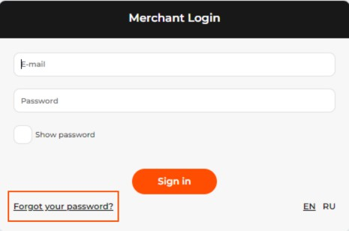
The ‘Forgot your password?’ button on the sign-in page

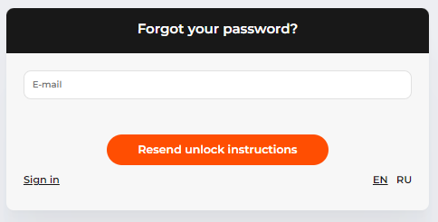
The page to set a new password

Select the interface language
The user interface of the system supports multiple languages. To select the interface language, click on the letter code of the language on the sign-in page.

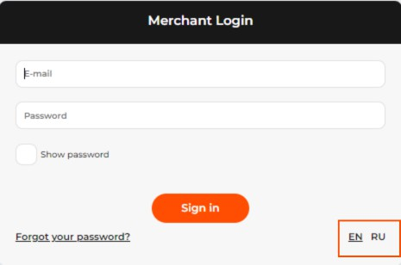

Set a user account
If necessary, you can change the following settings for your account:
- A username;
- An email address used as a login for authorization in the system;
- A password;
- Two-Factor Authentication Settings.

To make changes, follow these steps:
- In the account management area, click Edit profile.

- Change the account information. For a more reliable account protection, activate the Enable two-factor authentication checkbox, scan the QR code in your 2FA application and enter the token.
- Click Update to save changes or cancel them.

Managing access for your staff
To successfully manage the process of accepting payments, you can create additional accounts for your employees with access rights corresponding to their duties and tasks.

Employee access and account management is available on the Staff tab page.

View a list of staff accounts and their statuses
To view a list of employees, their account status and details, go to the Staff tab page. The system will show a list of your employees who have access to the system back office with brief information on each of them:
- Name: the name of the employee;
- Email: the employee's email address used as the login to the system;
- Status: an employee account status:
  - Enabled: The user can log in to the system;
  - Disabled: The account has been disabled;
  - Locked: The account has been locked out after 5 or more unsuccessful login attempts.
- Actions: Available actions with the user account.

To view detailed information about an employee's account, click Details in the line with employee data. You will be taken to a page with the following information:
- Name: the name of the employee;
- Email: the employee's email address used as the login to the system;
- Status: employee account status:
  - Enabled: The user can log in to the system;
  - Disabled: The account has been disabled;
  - Locked: The account has been locked out after 5 or more unsuccessful login attempts.
- Permissions:
  - Tabs: list of tabs to which the employee has access;
  - Shop: a list of stores to which the employee has access to transactions;
  - Actions: actions that an employee can perform in relation to transactions.
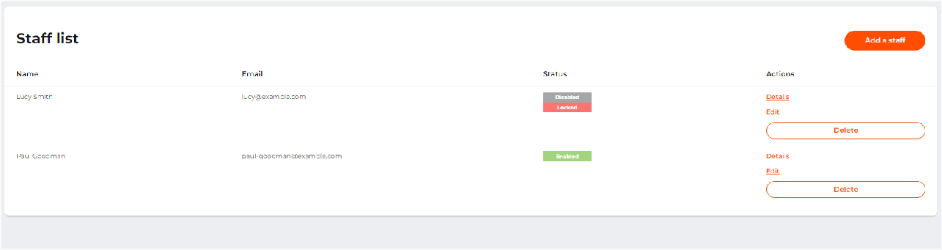
The list of staff accounts on the ‘Staff’ tab page

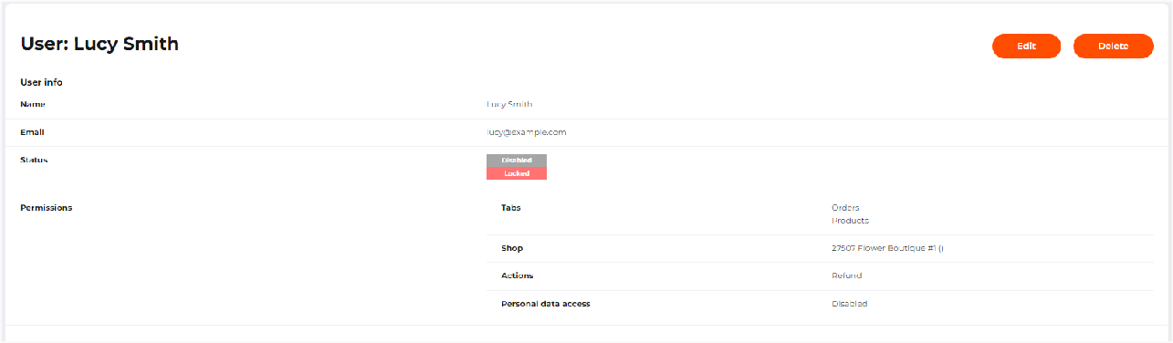
Details of a staff member account

Create an account for your staff
To register additional accounts for your employees, follow these steps:
- Go to the Staff page.
- Click Add a staff.
- Enter the data in the form, as described in the table below.
- Click Apply to save the settings or cancel them.

Table: Staff account parameters

Parameter | Description | Notes
Name* | An employee name.
Email* | An employee’s email. | Used as a login to the back office.
Permissions
Tabs | Specifying those menu tabs of the back office to which you want to grant access to an employee.  Possible values: Orders Reports Subscriptions Plans Products MOTO  Apple Pay Dashboard Balance v2 (beta)

You can use the registration form to grant your employees permission to certain menu tabs of your merchant back office, your shops, and actions in relation to transactions.

To grant permission to sections, select the necessary sections in the Permissions section.

Please activate checkboxes for a shop or several shops that the employee should have access to. This is necessary to provide the user with information only about those shops that the user has access to.

You can specify actions that the user can perform. To do this, in the Actions section, specify the functions available to the user:

Actions | Description
Refund | Allows the user to make refunds for payment transactions. To enable the user to perform the action, give permission to the Orders tab.
Capture | Allows the user to debit funds for two-step payments. To enable the user to perform the action, give permission to the Orders tab.
Void | Allows the user to cancel authorization transactions. To enable the user to perform the action, give permission to the Orders tab.
Close day | This parameter is not used.
White/Black lists | Allows the user to add or remove a customer card from the black or white list. To enable the user to perform the action, give permission to the Orders tab.
Personal data access | Personal data access permission  Users without this permission have no access to the customers' personal data: first name, last name, middle name, address, phone number, email, gender, data of birth, IP, cardholder as well as cardholder equivalent for alternative payment methods (for example, the owner of the wallet). The data are either masked or not displayed.  Also, the corresponding search fields are not displayed for the users without the permission.
Access to shop authorization credentials | Users without this permission do not have access to the shop’s public and secret keys.

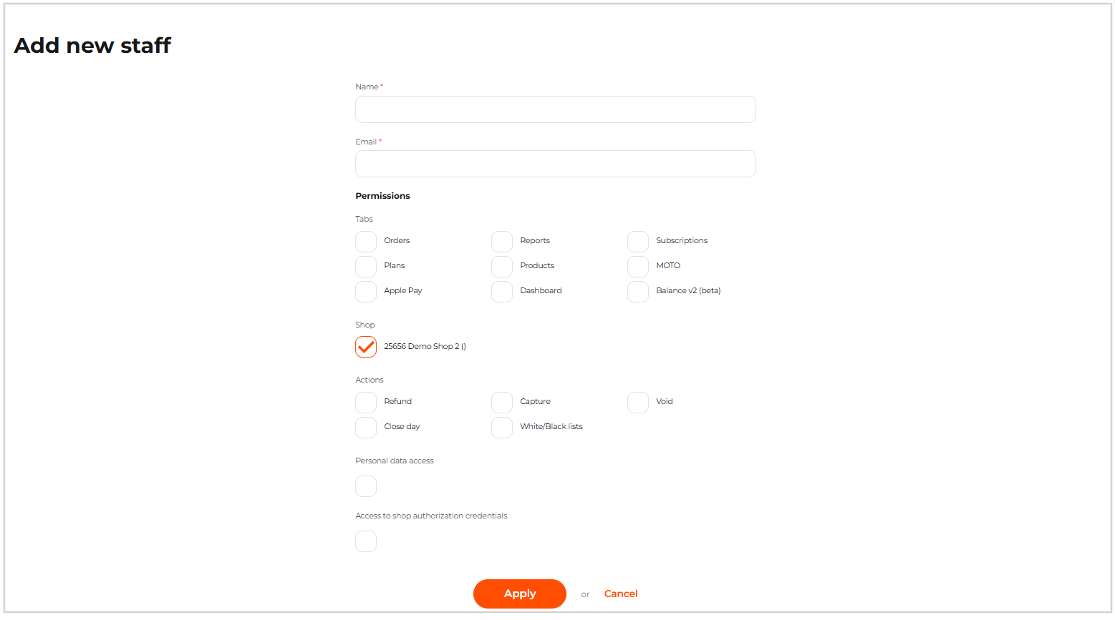
The ‘Add a new staff’ page

Once the user data are completed, the new user will receive an email with instructions and login credentials to the specified email address.

The number of users that you can add is not limited.

Edit and unlock a staff account
To edit an employee's account information, follow these steps:
- Go to the Staff tab page.
- Click Edit on the employee list row or on the employee details page.
- Make changes as described in Create an account for your staff. Deactivate the Locked checkbox to unlock access.
- Click Apply to save the settings.

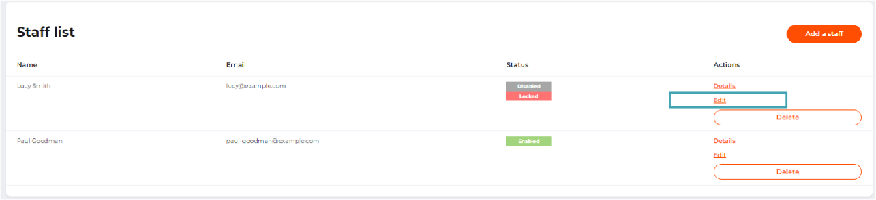
The ‘Edit’ button on the page with a list of staff accounts

Delete a staff account
To delete an employee account, follow these steps:
- Go to the Staff tab page.
- Click Delete on the employee list row or on the employee details page.
- Confirm the deletion.

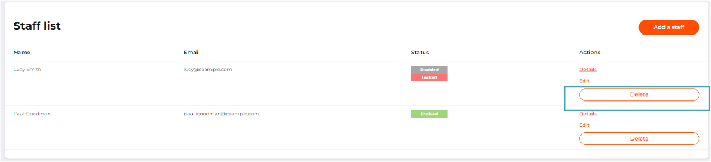
The ‘Delete’ button on the page with a list of staff accounts

Restrict system access based on IP address
The system lets you block the staff members from accessing the system unless their IP address is whitelisted.

When trying to sign into the system from an IP that is not whitelisted, the staff member will see the message Access from your IP address is restricted.
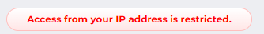

To add IPs of your staff members, go to the Staff tab and click Manage IP restrictions.

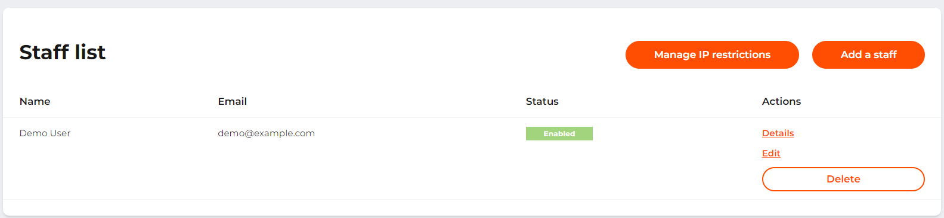

In the modal window, insert the IP addresses or the IP address ranges using CIDR notation. For example,
- to add the IP address, for example, 203.0.113.5, insert 203.0.113.5/32.
- to add an IP address range, for example, 203.0.113.0–203.0.113.15, insert 203.0.113.0/28.
- to add an IP address range, for example, 203.0.113.0–203.0.113.15 and IP address 203.0.113.18, insert 203.0.113.0/28,203.0.113.18/32.

Click Apply to save the settings.
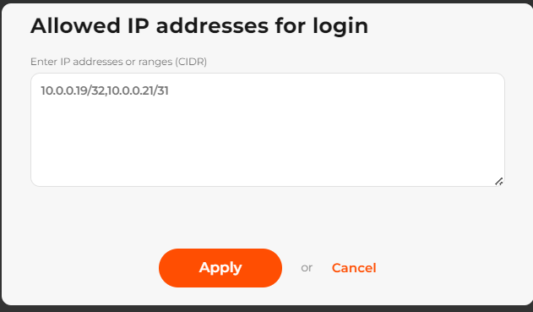

Shop management
A shop is the basic entity of the system, which refers to the merchant and its resource (a website or a mobile application). To accept payments, the merchant resource must meet the following requirements:
- To be registered in the name of the merchant;
- To contain information about the goods or services offered by the merchant, as well as about the merchant himself/ herself.

Registering a merchant shop in the system allows the following:
- To identify transactions made on a website or in a mobile application as payments made in favor of a merchant;
- To store the registration data of the merchant's shop in the system for analytical and reporting purposes, as well as for processing financial transactions;
- To connect and configure payment gateways, set up rates and limits for accepting and processing online payments on the website or in a mobile application;
- To set up tools and rules for checking transactions for fraud.

In the back office of the system, you can:
- view the list of registered shops;
- find out detailed information about the main shop parameters and settings;
- see the shop credentials required for integration with the system;
- set up transaction notifications;
- set up payment widget customization.

View a list of registered shops
In the back office of the system, you as a merchant or an employee of a merchant can view a list of all your shops that are registered in the system, with their basic data and settings.

To view a list of your shops, go to the Shops tab. On the tab page, you can see a summary of each shop as described in the table below.

Table: Parameters of basic shop settings

Parameter | Description | Notes
ID | The registration number of the shop in the system. | Assigned automatically in numerical order.
Status | The shop activation status. Possible values:  Enabled; Disabled. | For a detailed description of statuses, see the table below.
Name | The shop brand name. | Shown as a hyperlink to the shop information page.

Parameter | Description | Notes
Contacts | Shop contacts details that include: The Shop name;  The shop URL, if any; The shop contact email; The shop contact phone.
The shop can have one or several activation statuses, as described in the table below.

Table: Shop activation statuses

Status | Icon | Description
Enabled |  | The shop is activated. You can accept payments through the provider’s system.
Disabled |  | The shop is deactivated, payment transactions (Payment, Authorization, and Capture), payout transaction (Payout, Credit) and P2P are not accepted. Refund, Void, and Chargeback transactions are allowed both via the API and from your back offices.

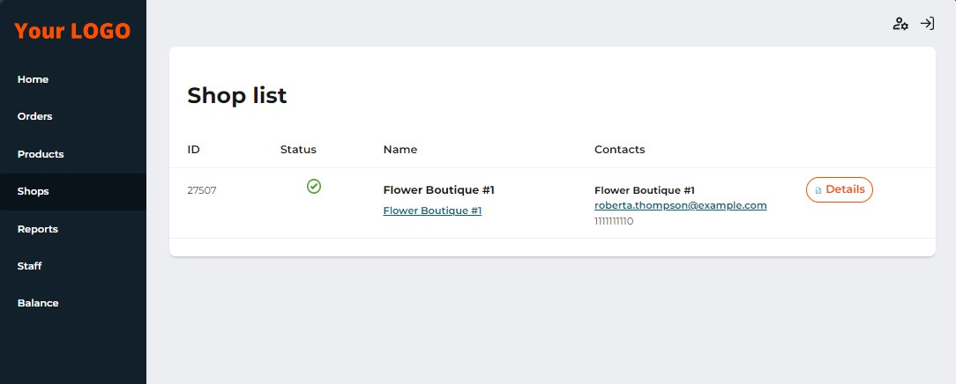
The ‘Shops’ tab page with a list of registered shops

View shop details and settings
To view detailed information about the shop and its settings, follow these steps:
- Go to the Shops tab.
- Select the desired store from the list and click Details.

On the shop information page, details are shown in the form of information sections, as described in the table below.

Table: Shop details and settings

Parameter | Description | Notes
Full info
Status | Possible values:  Enabled: the shop is activated;  Disabled: the shop is deactivated due to some reason.
ID | The registration number of the shop in the system. | Assigned automatically in numerical order. Used to authorize API requests.
Name | The shop brand name.
Business category | The business category of the shop.
Company name | The merchant's company name.
URL | The URL of the company or the shop.
Contact e-mail | The shop contact email, which can be used by customers to contact shop representatives or support, if needed.
Contact phone | The shop contact phone number, which can be used by customers to contact shop representatives or support, if needed.
Contact name | The shop representative name indicated upon shop registration.
Person, who entered the agreement | The name of the employee or contact person of the merchant entitled to enter into a contract on behalf of the company.
Title | The position of the employee or contact person entitled to enter into a contract on behalf of the company.

Parameter | Description | Notes
Acting on the basis of | Name, number, date of issue of the document on the basis of which the employee or contact person is entitled to enter into a contract on behalf of the company.
Tax Id | Taxpayer identification number.
Legal address | Legal address of the company (street, house, building, office).
Mailing address | The mailing address of the company.
Accountant email | The contact email address of an accountant or another person responsible for accounting.
Limits currency | The limit currency used to calculate the limit amounts. | Might be missing, if the limit service is not activated.
Bank account details
Bank name | The name of the bank or financial institution where your company’s current account for settlements is opened.
Bank Identifier Code (BIC) | Bank identification code.
International bank account number (IBAN) | International bank account number.
Conditional number of settlement participants | Conditional number of settlement participants.
Country | The country in which your company's current account is opened.
City | The legal address (city) of the bank or financial institution where your company's current account is opened.
Address | The legal address of the bank or financial institution where your company's current account is opened.

Parameter | Description | Notes
Postal code | The postal code of the bank or financial institution where your company's current account is opened.
Active brands
Active brand logos | Logos of brands and payment methods activated for the shop. | To add or remove brands from the list, contact your account manager.
3-D Secure brands
3-D Secure brand logos | Logos of brands and payment methods, for which the 3-D Secure verification check is activated.
Active currencies
Active currencies | A list of currencies, transactions in which can be processed by payment gateways activated for the shop.
Widget customization
Color of buttons | Color HEX-code for the widget and payment page buttons. | The color set by the provider is applied by default.
Background type | Widget and payment page background style. | The background set by the provider is applied by default.
3-D Secure rules
3-D Secure rules | The section contains information about the 3-D Secure security and anti-fraud rules, if they are set by your manager:  All cards: transactions made by all cards are processed regardless of 3-D Secure check results.  Only 3-D Secure card: payments by cards that do not support the 3-D Secure technology are rejected; Verification attempted: only those payments by cards that passed the 3-D Secure verification check successfully (“Y” status) are processed.

Parameter | Description | Notes
Fraud threshold
Fraud threshold | A set threshold of the MaxMind security and anti-fraud service. All transactions with a score higher than the threshold will be considered as fraudulent and will not be processed.
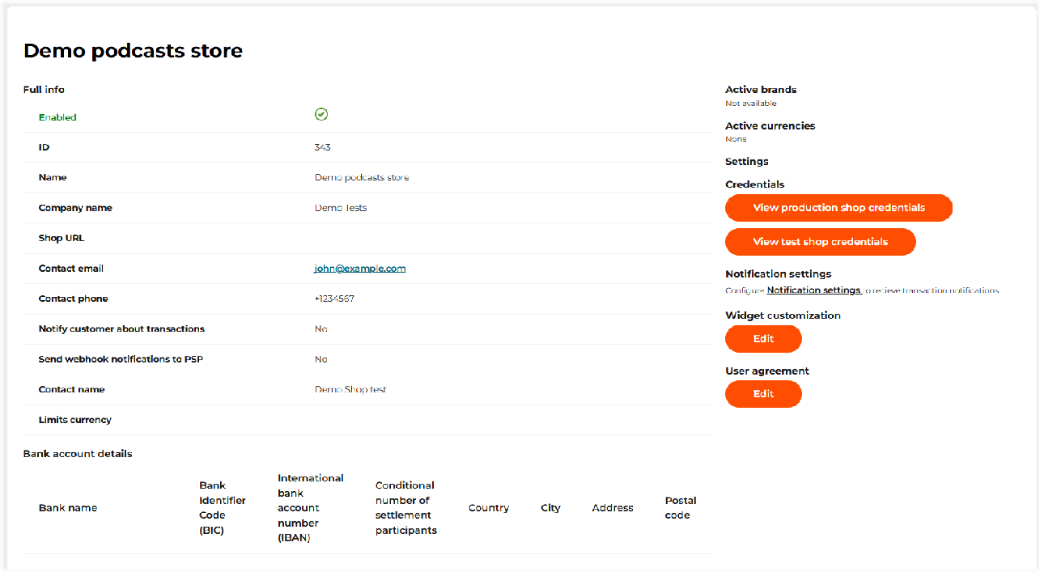
Shop details page

Shop details are specified by your account manager. Contact the manager if changes are required.

Get shop credentials
Shop credentials represent the main authorization data required to process payments. The credentials include the following:
- Shop ID is the shop registration number;
- Production shop credentials:
  - Webhook key – for verifying webhook signatures in the production environment;
  - Secret key is the shop secret key;

  - Public key is the shop public key. Please note that for shops created after the introduction of test and production credentials (June 2026), a public key is not generated by default.
- Test shop credentials:
  - Webhook key – for verifying webhook signatures in test mode;
  - Secret key is the shop secret key;
  - Public key is the shop public key. Please note that for shops created after the introduction of test and production credentials (June 2026), a public key is not generated by default.

To view and copy shop credentials, follow these steps:
- Go to the Shops tab.
- Select the desired shop from the list and click Details.

Shop ID is displayed as a shop ID in the Full info block.
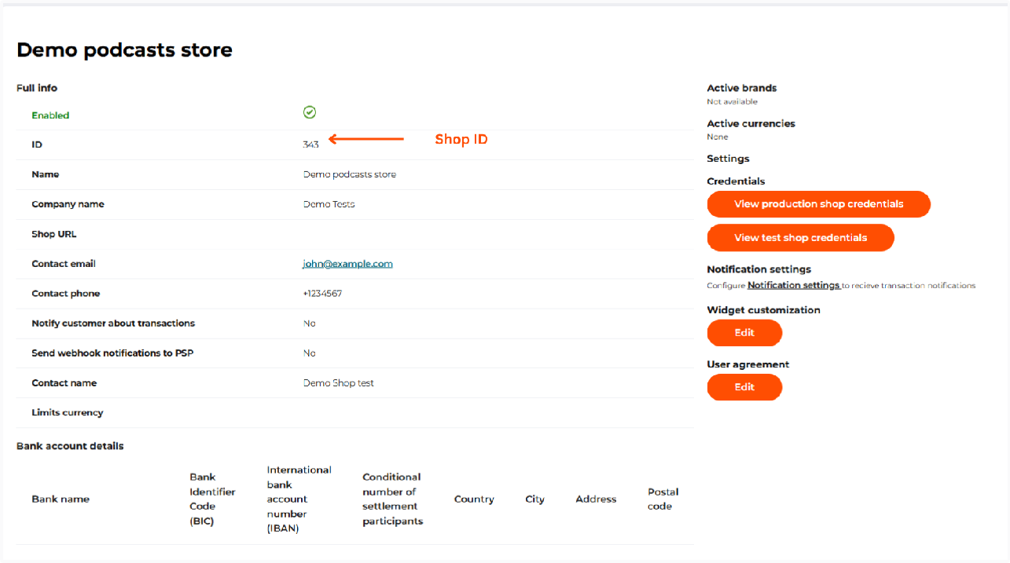
The Shop ID on the shop details page

To get production credentials, in the Credentials block of the shop information page, select View production shop credentials. View the keys in the pop-up window and copy them if needed.

If you suspect that a key might have been compromised, regenerate it.

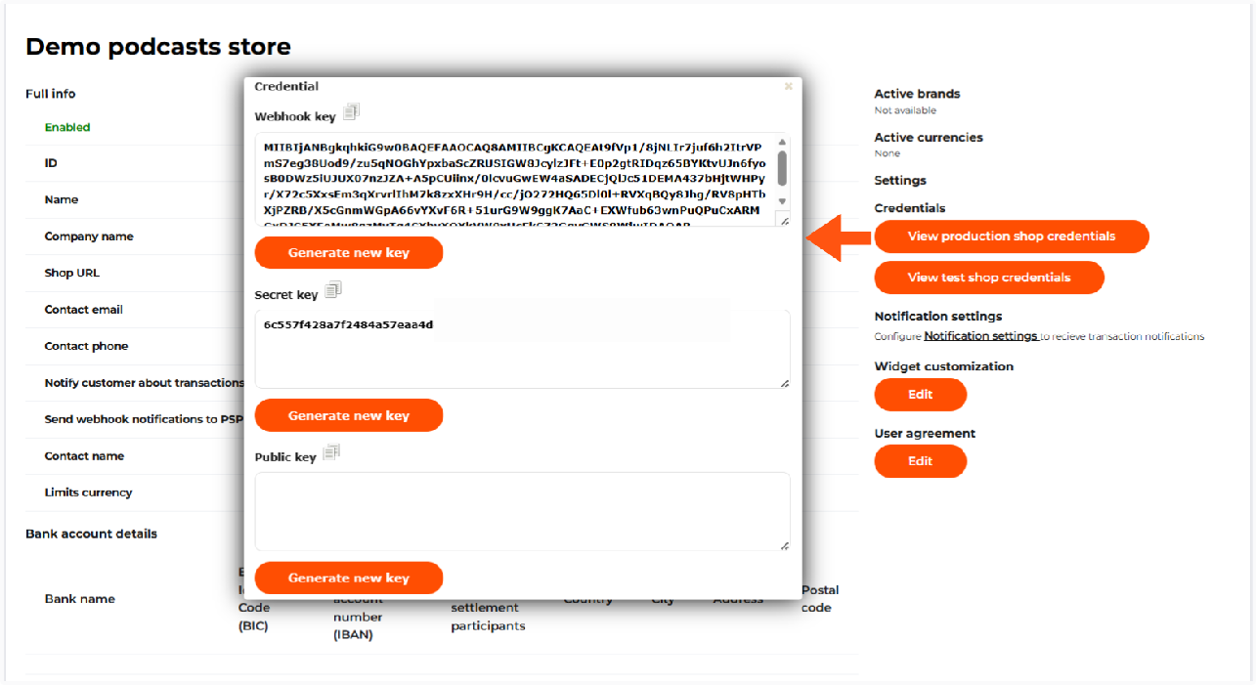

To obtain test credentials, click View test shop credentials in the Credentials section. Use these
"test": true

credentials to send requests with the related to such transactions.
flag and to verify webhook notifications

Please note that test and production credentials were introduced in June 2026. For shops created before that date, the key values in the test credentials block are identical to those in the production credentials block. It is recommended to generate new keys for the production environment.

Notification settings
Notification settings let merchants and their customers get the up-to-date information on transactions processed by the system for their shops.

The system supports 3 notification types:
- notification to the merchant’s URL;
- notifications to the merchant’s email;
- notifications to the customers' emails indicated when they make a purchase.

To set up notifications, follow these steps:
- Go to the Shops tab.
- Select the desired store from the list and click Details.
- Click Notification settings in the settings block.
- On the page that opens, specify the parameters, as described in the table below.
- Click Update settings or cancel them.

Table: Notification setting parameters

Parameter | Description | Notes
Notification URL | A URL to which the system will send transaction notifications. | This URL can also be set in transaction requests as the value of the  notification_url  parameter.
Verification URL | Once the transaction request is sent by a merchant to the system, the system will send the transaction verification request to the provided URL (for example, to make sure the merchant has enough items available). Once the system will get the 200 HTTP status code from the merchant, it will send the request to the bank/payment provider. If the merchant also sends  verification_url in the API request, the value in the request will override the value in this field.  If the merchant doesn’t respond to the verification request with a successful status, the transaction  gets a failed status. | Example of a successful response to the transaction verification request:  {  "code":0,  "uid":  "35153123-9367e7e770",  "amount": 100, "created_at":  "2024-08-04T06:16:17.05 2Z"  }
Card data update notification URL | A URL to which the system will send a notification if the card data has been updated, for example, if the card issuer changes the card art and informs Visa/Mastercard about it.  If the URL is also sent in the transaction request in  credit_card.notification_url parameter or in the payment token request in  settings.card_notification_ur  l parameter, the notification will be sent only to the URL specified in the request. | The field is available only if SCOF and VTS services are activated for the PSP.
Notification e-mail | An email to which the system will send transaction notifications. | 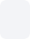  If required, indicate various emails. Use , to separate them.

Parameter | Description | Notes
Deliver transaction notification e-mail about
Payment | Select the transaction type to get notifications when the system processes payments.
Authorization | Select the transaction type to get notifications when the system processes authorizations.
Capture | Select the transaction type to get notifications when the system processes captures.
Refund | Select the transaction type to get notifications when the system processes refunds.
Chargeback | Select the transaction type to get notifications when the system processes chargebacks.
Credit | Select the transaction type to get notifications when the system processes credits.
Payout | Select the transaction type to get notifications when the system processes payouts.
P2P | Select the transaction type to get notifications when the system processes P2P transfers.
Deliver customer  notification e-mail | Select the option to get your customers notified of transactions by email. Notifications will be sent to customers' emails indicated for orders and purchases.

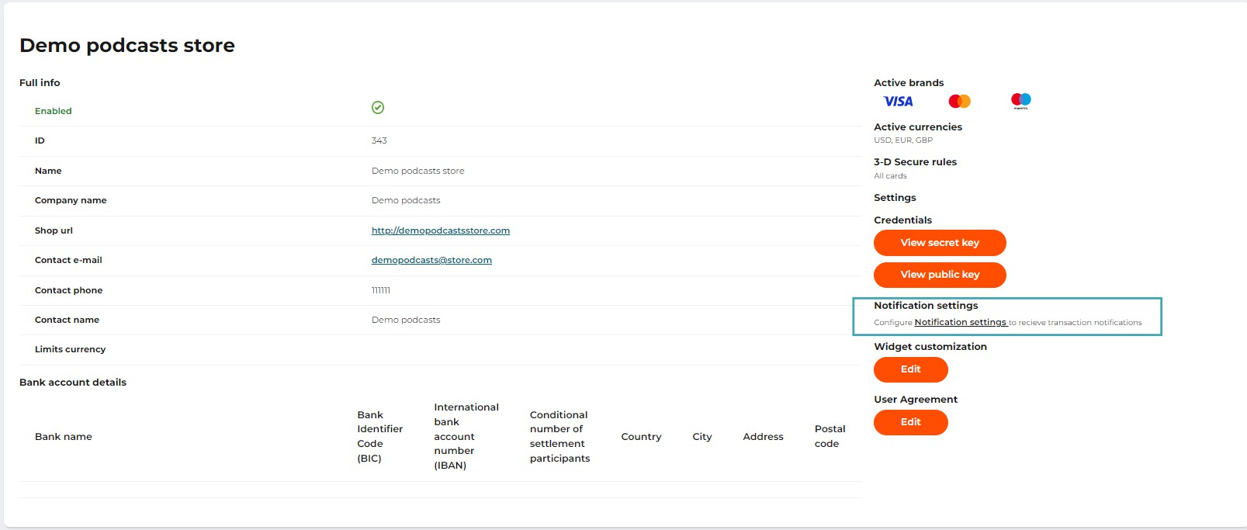
The ‘Notification settings’ block on the shop details page

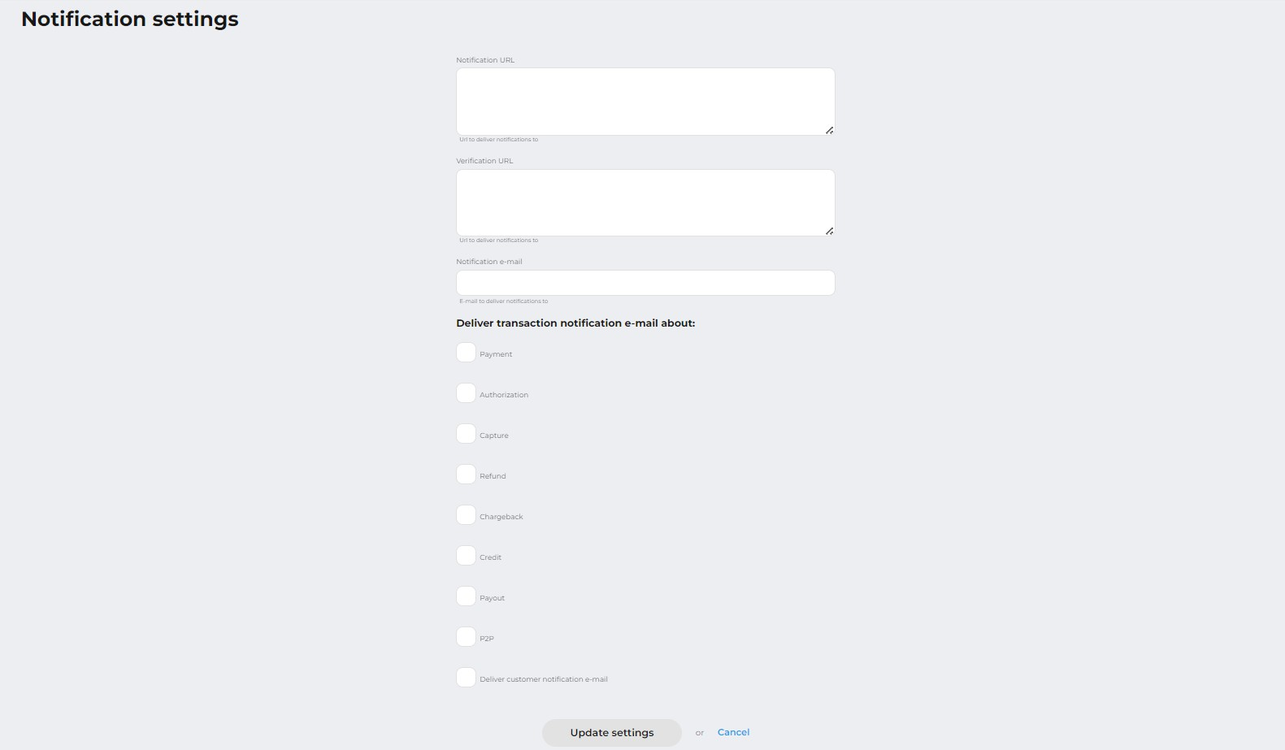
The ‘Notification settings’ page

Widget customization
When using the payment widget v.2, the merchant can customize the widget and the payment page. For the basic widget customization, in the back office it is possible:

- to set the color of the payment confirmation button and of the background type;
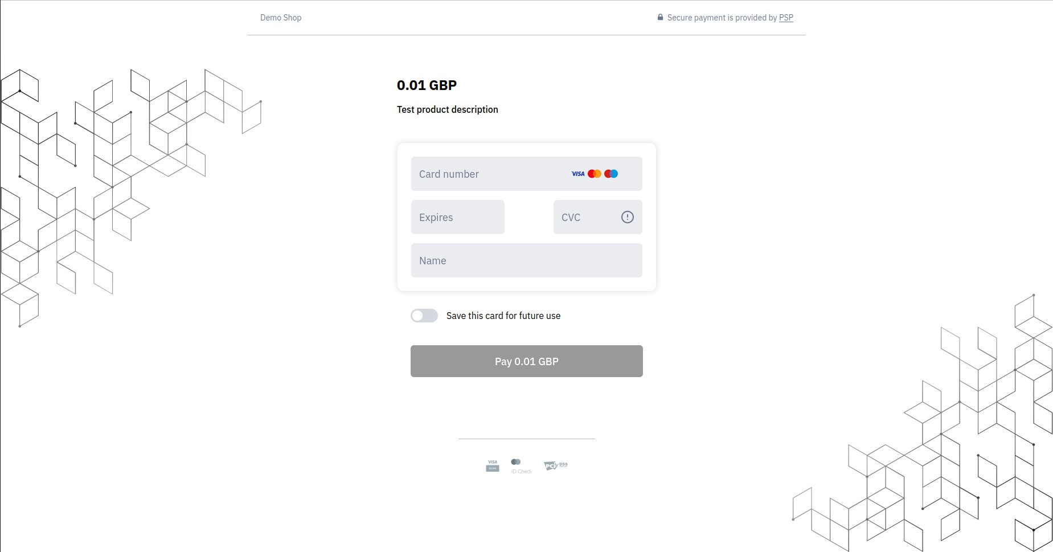
- to choose the background type.

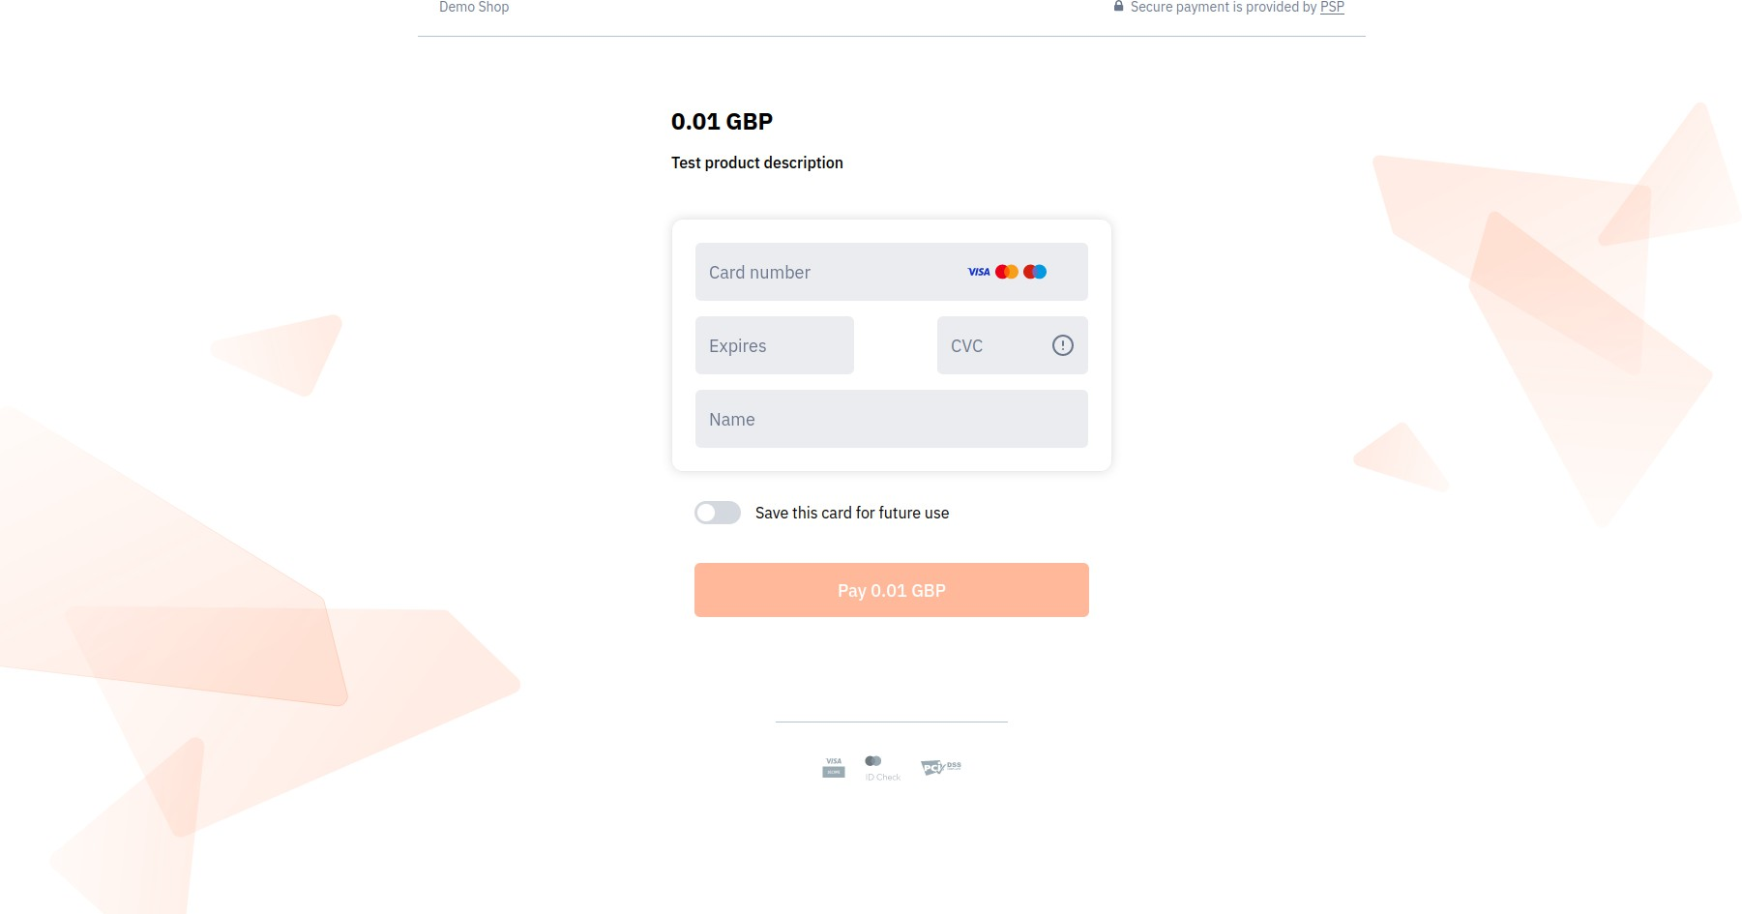
Sample widget on the payment page ( #000000 as a color of buttons and Rhombus as a background type applicable)

Sample widget on the payment page ( #FF4E02 as a color of buttons and Shards as a background type applicable)

To customize the widget, follow the steps below:
- Go to the Shops tab.
- Select the desired store from the list and click Details.
- Click Edit in the Widget customization section.
- Specify the widget customization options, as described in the table below.
- Click Apply to save your changes or discard them.

Table: Parameters of the basic widget customization

Parameter | Description | Notes
Color of buttons | Color HEX-code. | If not set, the default system color set by the payment service provider is applicable.

Parameter | Description | Notes
Background type | Possible values are:  Random: a random choice of the background type;  Shards:    Rhombus:    Ovals:    Triangles: | If not set, the default system color set by the payment service provider is applicable.

Parameter | Description | Notes
 | 

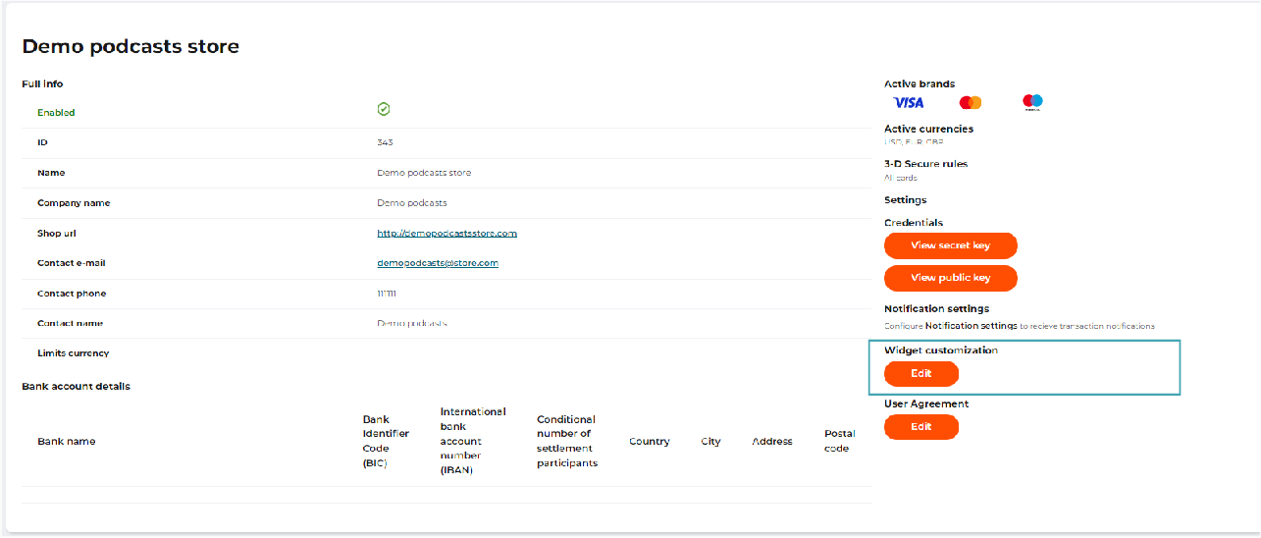
The ‘Widget customization’ block on the shop details page

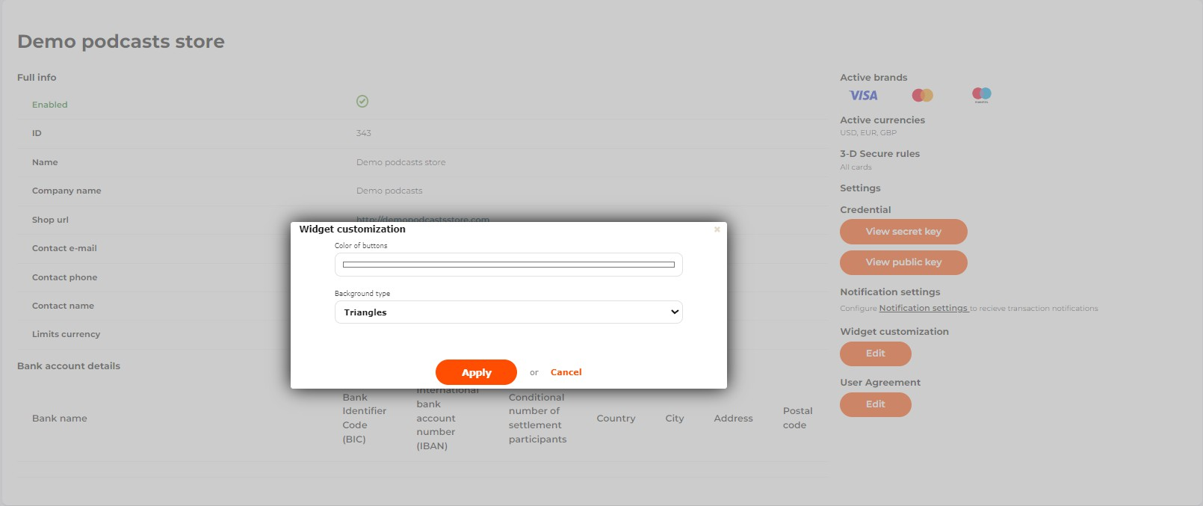
The ‘Widget customization’ window

User Agreement settings
To add the User Agreement toggle to the widget, follow the steps below:
- Go to the Shops tab.
- Select the desired store from the list and click Details.
- Click Edit in the User Agreement section.
- Specify the User Agreement settings, as described in the table below.
- Click Update to save your changes or discard them.

User Agreement
Use the User Agreement | The option to display User Agreement toggle on the Order confirmation pages that are generated for plans and products. | The Pay button is deactivated unless the customer clicks the toggle confirming that they accept the User Agreement.
URL to the User Agreement | URL to the page with the text of the User Agreement. | If both URL and file are provided, the text will link to the URL.

Switch text | Text that will be placed next to the User Agreement toggle. Fill in the  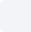  field according to the example: I agree to the terms and conditions of [the User  Agreement] .  In this case the link will either open the attached file or the provided URL in a separate tab. | 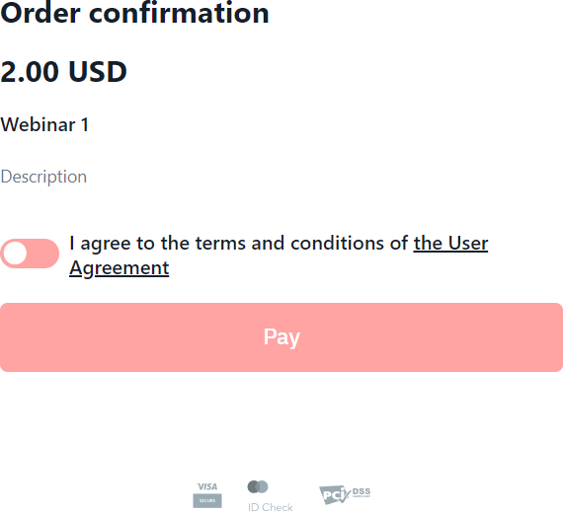
User Agreement file | The button for uploading the PDF file with the User Agreement. The file size must not exceed 1MB. If the file size is bigger, it is recommended to provide a URL to the User Agreement instead. | If both URL and file are provided, the text will link to the URL.
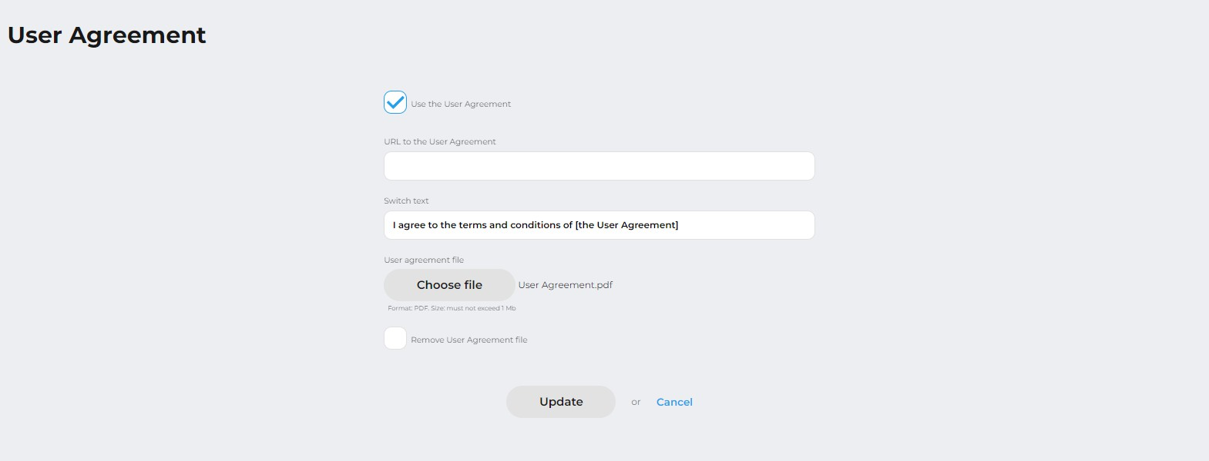

Setting up payment methods, subscriptions and products
For you as a merchant, to accept online payments for your goods and services offered in the shop, it should be connected to one or more payment gateways.

A payment gateway is a dedicated channel provided by an acquirer for secure processing of transactions which are initiated by customers to pay for goods and services that merchants offer in their shops.

To activate a payment gateway for transaction processing, you must specify a unique set of authorization data in the system. Each merchant receives these credentials independently or with assistance of the payment service provider. The credentials are issued by an acquirer who provides a payment gateway to the merchant.

A bank or a payment service provider, who provides a payment gateway to a merchant, might have processing restrictions or limited opportunities or impose those on a payment gateway. It may concern the following:
- Supported types of transactions and processing flows;
- Supported payment brands and methods;
- Supported currencies;
- Limits on the total amount of payments per month;
- Limits on the maximum and minimum amount of a transaction, etc.

Payment gateways for your shop are configured by your account manager. You can see these settings on the shop information page. If you have questions about the brands, payment methods, currencies, or transaction processing schemes, activated for your shop, please contact your account manager.

Payment links for products
The payment gateway offers several types of integration for accepting payments, such as direct integration, payment page, SDK for mobile applications. For our clients, we offer ready-made libraries or embedded modules for all types of integration. However, these modules must be connected by a qualified IT specialist.

For those who'd like to start accepting payments without a complex integration, the ACME system offers merchants to use payment links. You can create payment links in your backoffice and send them to your customers in order that they can complete a payment.

To get a payment link, you should create a product first. In the ACME system a product is a record for a physical product or a service, for which you want to accept payments via payment links.

Create a product
To register a product or service that your customers will pay for via a payment link, follow these steps:
- Go to the Products tab.
- Click Add a product.
- Fill out the product form, as described in the table below.
- Click Apply to save the product.

The added product will appear in the product list.

Table: Product parameters

Parameter | Description | Notes
Name | The product name.
Description | A brief description of the product.
Currency | A payment currency.
Amount | A product price in the payment currency.
Quantity | Number of product units available. Specify if the Infinite option is inactive. | Each time a customer goes to the payment page, 1 unit of the product is “reserved” for 15 minutes. This eliminates overbooking of the same product. If the payment failed or the user was inactive on the payment page for more than 15 minutes, the “reserved” product becomes available for purchase.
Infinite | Indicates that the product quantity is unlimited.
Visible fields | Specify the fields to be filled in by the payer when making the payment.
Test | Check this box if you are creating a test product. | Transactions for test products are not displayed in reports.
Unlimited payment period | Check this box if you don't have a time limit for paying for the product. If there is a time limit, fill in the Expiration date field.

Parameter | Description | Notes
Expiration date | Allows you to limit the payment period to a certain date. | The field is hidden, if you check the box Unlimited payment period.
URL where to return a customer if a payment is success | Specify the URL where to return a customer if a payment is successful. | You can choose to redirect the buyer to the main page of your site, or give a link to the product, or any other link. If the URL is not indicated, the system will redirect customers to the main page of your website.
URL where to return a customer if a payment is failed | Specify the URL to redirect the buyer to after a failed payment. | You can choose to redirect the buyer to the main page of your site, or give a link to the product, or any other link. If the URL is not indicated, the system will redirect customers to the main page of your website.
Shop | A name of the shop, for which the product is created. | The field is shown, if you have several registered shops.
Language | Specify the language of the payment page.
Transaction type | Set the transaction type. Possible values:  Payment: immediate debiting.  Authorization: blocking of funds on the customer's account with subsequent capture or void. | If the total amount for the product may change, we recommend using the Authorization transaction.

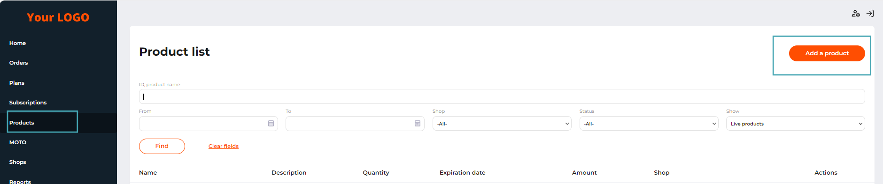
The ‘Add a product’ button on the ‘Products’ tab

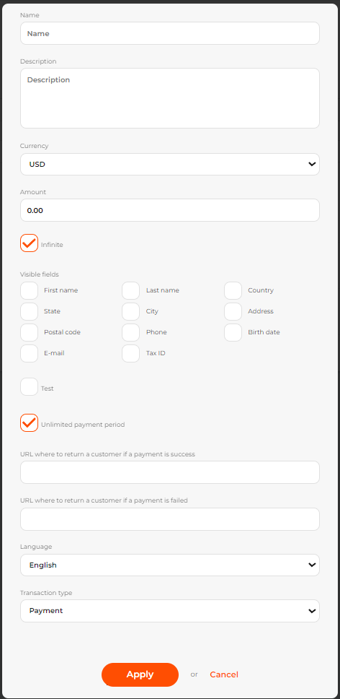
The 'Add a product' tab

If you don't see your new product on the list, make sure that the Show filter value at the top of the page matches the type of Subscription you created.

View and edit product settings
To view and edit the parameters of an earlier created product that customers will pay for via payment links, follow these steps:
- Go to the Products tab page.
- If there are many products, please specify the search parameters, as described in the table below.
- Click Search.

Table: Product search parameters

Parameter | Description
ID, product name | A product ID or its description.
From | A start date of the product search period based on the product creation date.
To | An end date of the product search period on the product creation date.
Shop | A shop for which the product is registered. Possible values:  All: to show products of all shops; Shop name: to show products of the selected shop only.
Status | A product status. Possible values:  All: to show products of all statuses; On offer: to show products that are available for sale;  Out of stock: to show products out of stock;  Outdated: to show products that can not be paid for anymore.
Show | Possible values:  Live products: to show products created for sale only;  Test products: to show products created for tests only.
The system will display a list of products matching the search criteria, with the following brief information about each:
  - Name: the product name;

  - Description: the product description;
  - Quantity: the number of products in stock;
  - Expiration date: the period until which it is possible to pay for the product;
  - Amount: the cost of the product;
  - Shop: The shop for which the product was registered.
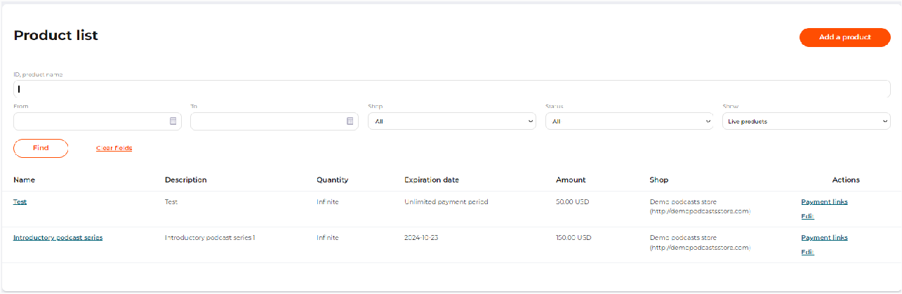
The ‘Products’ tab with a list of added products

For detailed information about a product, click on the name in the product line. The system will show you the following information:
  - ID: the product identification number assigned by the system;
  - Name: the product name;
  - Description: product description;
  - Amount: the cost of the product;
  - Creation date: the date of registration of the product in the system;
  - Quantity: the number of products in stock;
  - Expiration date: the period until which it is possible to pay for the product;
  - Language: the language of the product payment page;
  - URL where to return a customer: the URL that the customer will be taken to after the payment is completed;
  - Transaction type: the type of transaction that will be carried out when paying for the product.

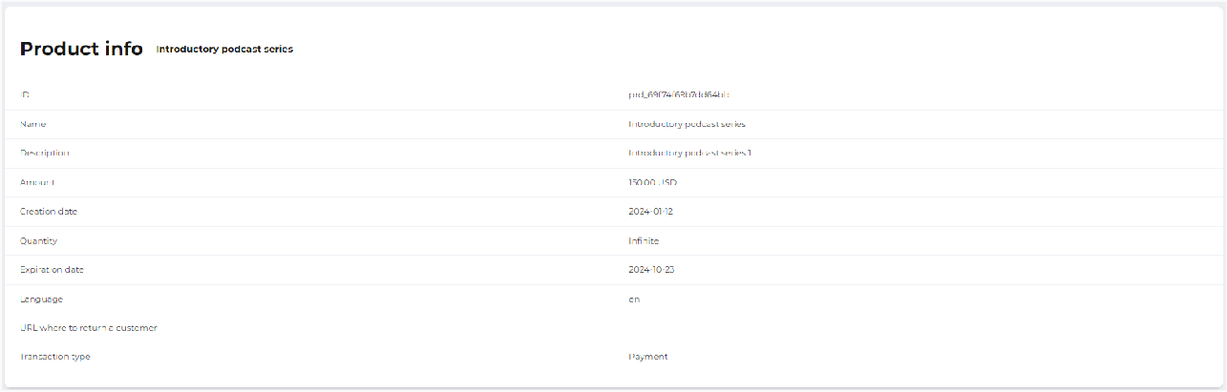
Product info page

To edit product parameters, follow these steps:
- Go to the Products tab page.
- If there are many products, please specify the parameters for searching the product according to the description of the fields in the table above.
- Click Search.
- Click Edit on the product line.
- Change the settings as described in Create a product.
- Click Apply to save your changes.

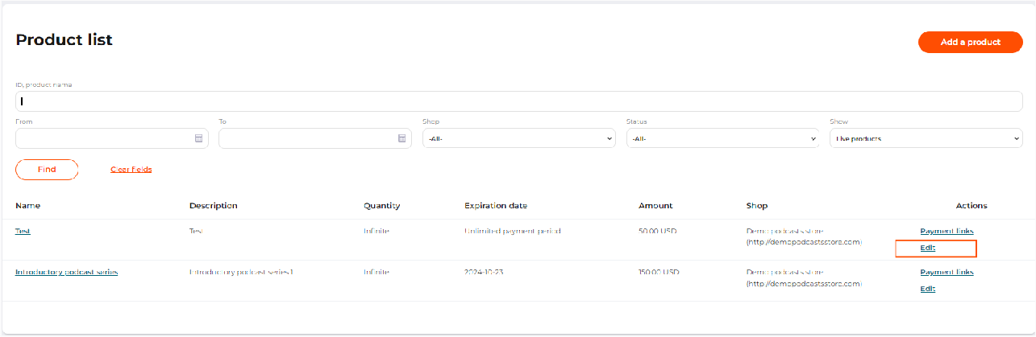
The ‘Edit’ button in the products list

Get a product payment link
For each registered product registered, the system automatically generates a payment link that can be copied and sent to customers.

To get a payment link for a product, follow these steps:
- Go to the Products tab page.

- If there are many products, please specify the parameters for searching the product according to the description of the fields in the table below.
- Click Search. The page display panel will display a list of store products that match the search criteria.
- In the row of the desired product, click Payment links.
- Copy the relevant link.

For each product the system generates 2 payment links:
  - Product payment link ( ),
confirm_url
  - Payment links for websites and mobile applications ( ).
pay_url

If you notify your customers of order and payment details over email or a messenger, use a
product payment link ( ). The customer has to confirm the order before s/he is
confirm_url
redirected to a secure page with a payment widget to complete a payment.

In other case, copy and integrate a payment link for websites and applications ( ). The
pay_url
link refers to a secure page with a payment widget, where the customer can enter payment data.

Table: Product search parameters

Parameter | Description
ID, product name | A product ID or its description.
From | A start date of the product search period.
To | An end date of the product search period.
Shop | A shop for which the product is registered. Possible values:  All: to show products of all shops; Shop name: to show products of the selected shop only.
Status | A product status. Possible values:  All: to show products of all statuses; On offer: to show products that are available for sale;  Out of stock: to show products out of stock;  Outdated: to show products that can not be paid for anymore.

Parameter | Description
Show | Possible values:  Live products: to show products created for sale only;  Test products: to show products created for tests only.

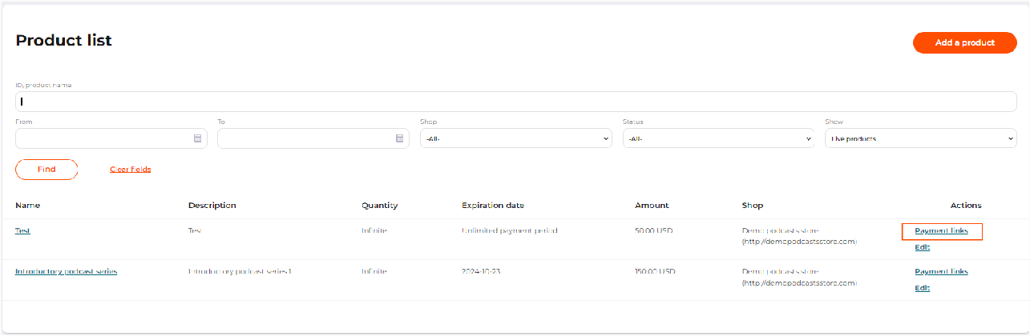
The ‘Payment links’ button in the Product list
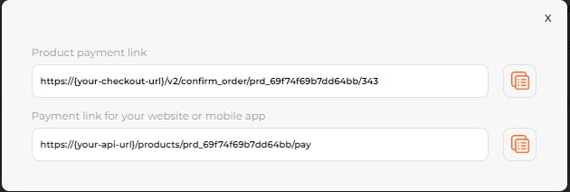
A pop-up window with payment links

 Each time a customer goes to the payment page, 1 unit of the product is “reserved” for 15 minutes. This eliminates overbooking of the same product.
If the payment failed or the user was inactive on the payment page for more than 15 minutes, the “reserved” product becomes available for purchase.

Plans
Using the payment service provider system, you as a merchant can both accept one-time payments for your goods or services, and also create plans for accepting recurring payments.

A plan is a description of the scheme and parameters for charging funds from customers' cards for goods and services on a regular basis.

To track payments made by a customer, the system creates a subscription as a list of the customer’s payments under a plan. A detailed description of the subscription service can be found in Subscriptions.
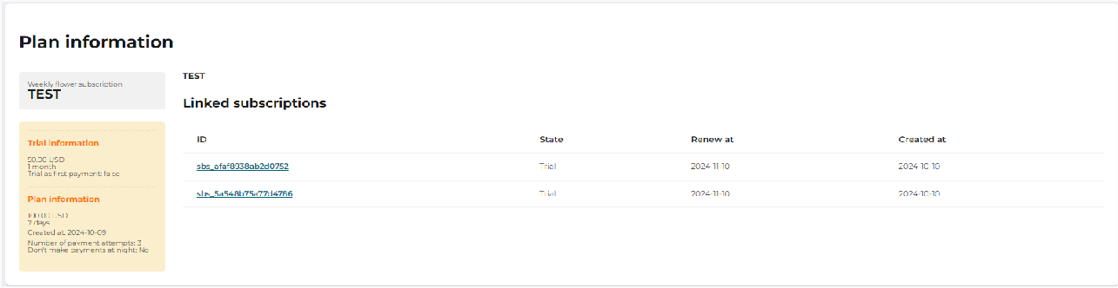
The ‘Plan information’ page

Create a plan
To create a plan, follow these steps:
- Go to the Plans tab page.
- Click Add a plan.
- Fill out the form according to the description of the fields in the table below.
- Click Confirm to save the settings.
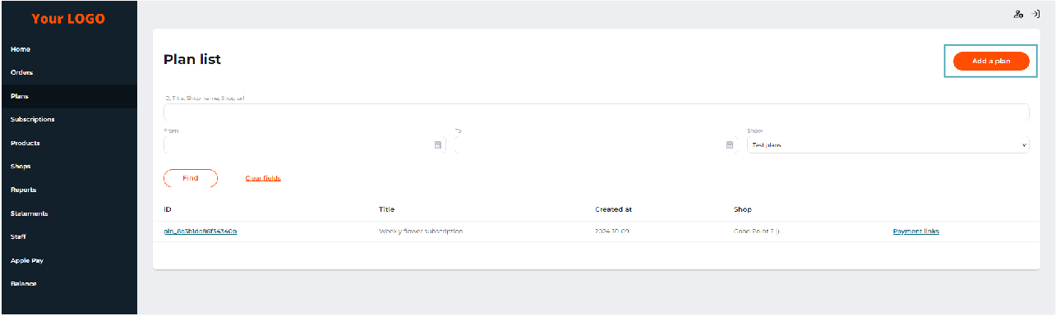
The ‘Plans’ tab and the ‘Add a plan’ button

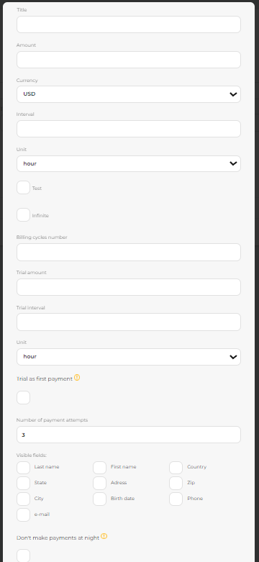

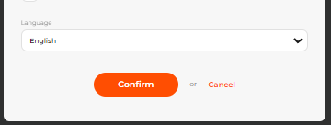
The form for adding a new plan

When creating a plan, please specify:

Table: Plan parameters

Parameter | Description
Shop | Select the shop you want to create a plan for. This field is available if the merchant has more than one shop.
Title | A plan name.
Amount | An amount or recurring debiting.
Currency | A currency of recurring debiting.
Interval | An interval for recurrent charges.
Unit | Unit of measurement for the recurrent debiting.
Test | If this option is enabled, the plan is a test plan.
Infinite | If this option is enabled, the number of subscription renewals is unlimited.
Billing cycles number | This field is available if the Infinite option is disabled. Set the number of billing cycles for each user.
Trial amount | The amount that will be debited for enabling the test period.
Unit | A time unit for the trial period (hours, days, months).

Parameter | Description
Trial as first payment | If the Trial as first payment option is not enabled, the system will deactivate the subscription after the trial period if the first attempt to withdraw funds for the regular period is unsuccessful (for example, insufficient funds).  If the Trial as first payment option is enabled, the system considers the payment for the trial period as the first regular payment. Thus, the system will constantly attempt to withdraw funds, but the subscription will not be cancelled automatically (the customer will be able to continue using it without paying). This increases the risk of using stolen, "single-use" cards and cards with an insufficient balance. If the customer is conscientious, the bank will send the customer a notification of insufficient funds (for example, via SMS), and the customer can top up his balance to pay for the subscription.
Number of payment attempts | After the number of payment attempts exceeds the number specified in the field, the subscription is cancelled.
Visible fields: first and last name, country, state, address, zip, city, birth date, phone, email | Fields visible to the client during the payment. All the selected fields except phone are required.
Don’t make payments at night | If the option is active, the system charges customers only during the period from 8:00 AM to 8:00 PM in the time zone set for the system by the payment service provider.
Language | Set the language of the payment page.

Search and view plan details and settings
To view and edit the settings for a created plan that customers will pay via payment links, follow these steps:
- Go to the Plans tab page.
- You have many plans, specify the parameters for searching for a plan according to the description of the fields in the table below.
- Click Find.

Table: Plan search parameters

Parameter | Description
ID, Title, Shop name, Shop URL | A field for specifying the identification number of the plan, its name, or details of the shop for which the plan is registered.

Parameter | Description
From | An end date of the plan search period based on the plan creation date.
To | An end date of the product search period on the plan creation date.
Show | Possible values:  Live plans: to show plans created for sale only;  Test plans: to show plans created for tests only.
The system will display a list of plans matching the search criteria, with the following brief information about each:
  - ID: a plan identification number;
  - Title: a product name;
  - Created at: a plan registration date;
  - Shop: a shop for which the plan was registered.
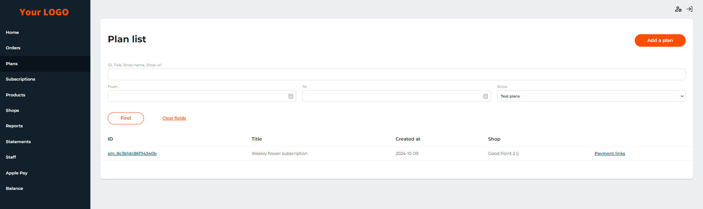
The list of plans on the ‘Plans’ tab

For detailed information about the plan, click on its ID in the line of the plan. The system will show you plan settings and related subscriptions. For more information about subscriptions, see Subscriptions.

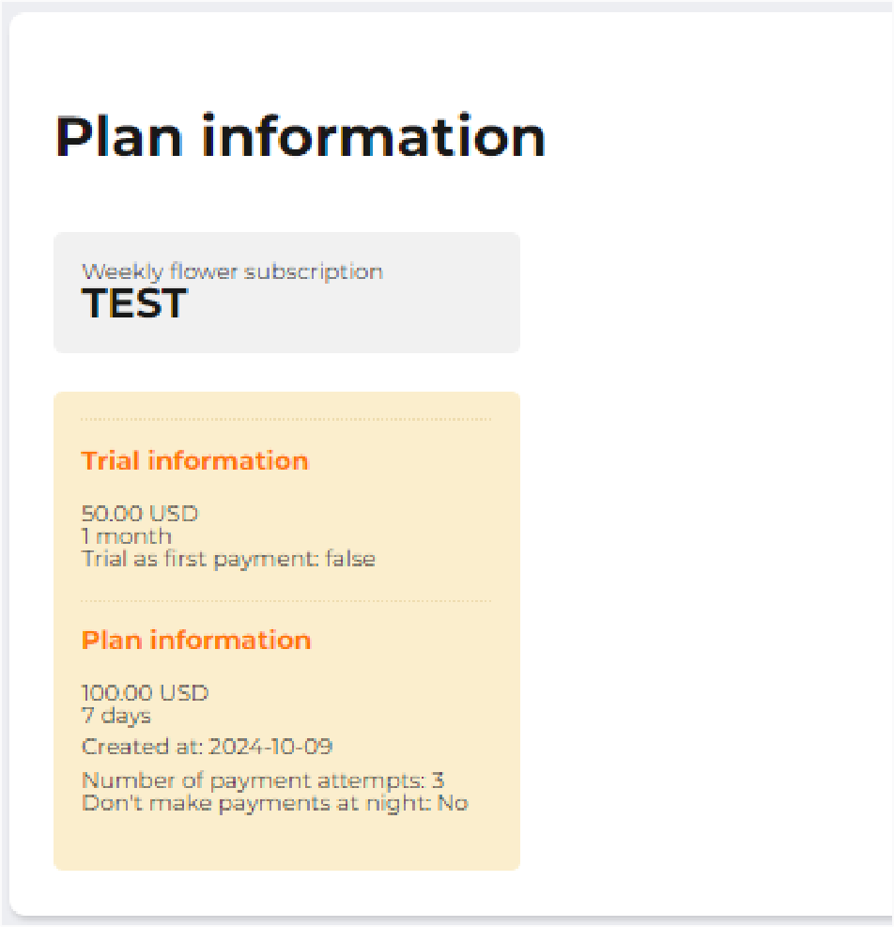
The plan settings and details

Get a plan payment link
For each registered plan, the system automatically generates a link that can be copied and sent to customers.

To get a payment link to pay for the plan, follow these steps:
- Go to the Plans tab page.
- If you have many plans, specify the parameters for searching for a plan according to the description of the fields in the table below.
- Click Find. The page display panel will display a list of shop plans that match the search criteria.
- In the row of the desired plan, click Payment link.
- Copy the link to the payment page.

A link to pay for the plan can be sent to the payer or embedded into your website. When a customer makes the first payment, the system will automatically save the card details for subsequent charges. No additional actions are required to save customer card data.

Table: Plan search parameters

Parameter | Description
ID, Title, Shop name, Shop URL | A field for specifying the identification number of the plan, its name, or details of the shop for which the plan is registered.
From | An end date of the plan search period based on the plan creation date.
To | An end date of the product search period on the plan creation date.
Show | Possible values:  Live plans: to show plans created for sale only;  Test plans: to show plans created for tests only.

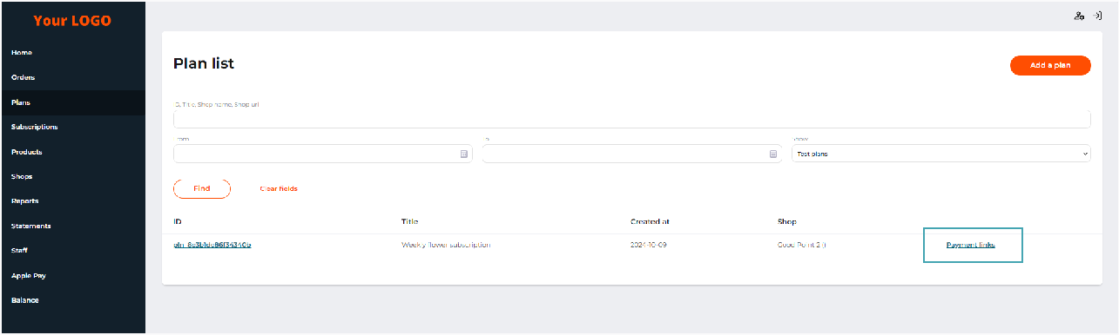
The ‘Payment links’ button in the plans list

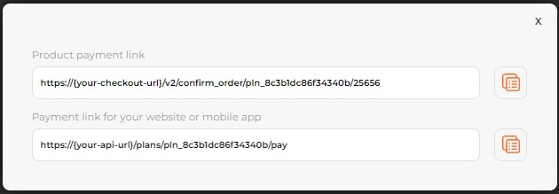

Subscriptions
A window with payment links for the plan

To account for the customers' recurring payments for goods or services, the system offers a service of plans and subscriptions.

A subscription is a rule that describes the amount and frequency of debiting funds from the customer's card. The amount and regularity are set in the plan to which the subscription is directly linked.

After the first attempt of the customer to make a payment according to a given plan, the system automatically creates a subscription. Each subscription is associated with a chain of transactions of only one customer.

The merchant can track recurring payments on the Subscriptions tab page, which shows all linked transactions of the plan. Detailed information about creating plans can be found in Plans.

Search for a subscription
To search and view customer subscriptions, follow these steps:
- Go to the Subscriptions tab page.
- Specify the subscription search parameters as described in the table below.
- Click Find.
- To search for another subscription, click Clear fields and repeat the instructions from step 2.

Table: Subscription search parameters

Parameter | Description
Search field | A field to search across a subscription ID, Title, Shop name or URL.

Parameter | Description
State | A subscription status. Possible values:  All: to show subscriptions of all statuses;  A subscription status: to show subscriptions of the selected status only.  See all possible subscription statuses in the table below.
From | A start date of the search period based in the subscription creation date.
To | An end date of the search period based on the subscription creation date.
The page will show all customer subscriptions that match the search criteria, with the following summary:
  - ID: a subscription identification number;
  - Title: the name of the subscription;
  - State: a subscription status according to the table below;
  - Created at: a date the subscription was created;
  - Renewed at: a date of the next subscription payment;
  - Shop: The name and URL of the shop that the plan was paid for.

Table: Available subscription statuses

Status | Description
Trial | The subscription is in the trial period.
Active | The subscription is active, the customer successfully pays for the goods or services.
Failed | The subscription failed. The system could not successfully debit the customer’s card for the set number of transaction attempts.
Cancelled | The subscription is cancelled, and there will be no more debits from the customer's card. For more information, see View subscription details, cancel a subscription.
Failed attempt | A transaction to pay for a subscription failed or is in the incomplete status.

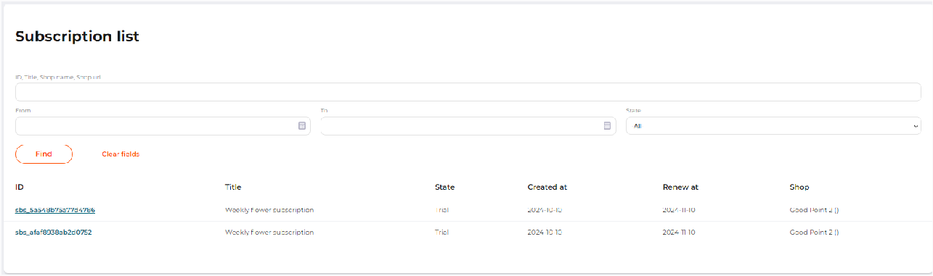
The ‘Subscriptions’ tab page

View subscription details, cancel a subscription
To search and view customer subscriptions, follow these steps:
- Go to the Subscriptions tab page.
- Specify the subscription search parameters as described in the table below.
- Click Find.
- Click the required Subscription ID.

Detailed subscription information includes the following data:
  - the title and information about the plan to which the subscription belongs;
  - a subscription status;
  - a list of customer transactions related to the subscription.

Besides, on the subscription details page for active subscriptions, there is a Cancel button to cancel the subscription.

The subscription can be canceled in several cases:
- Automatic cancellation. If the client does not have enough funds on the account to pay for the next recurring payment, the system will try to debit funds from the card every day as many times as specified in the Number of payment attempts parameter. Once the attempts are exhausted, the subscription will be automatically canceled. If needed, make a new one.
- Cancellation of a subscription by a customer. The client can cancel the subscription on his/her own by clicking on the link in the email notification of the payment.
- Cancellation of a subscription by a merchant. Click Cancel in the plan information box on the subscription details page.

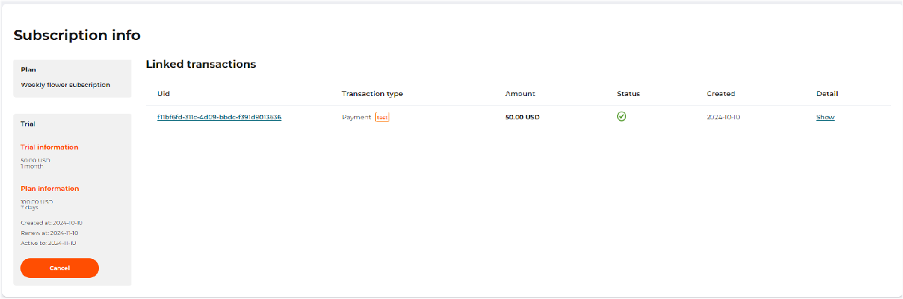
The ‘Subscription info’ page

To go to the subscription settings, click on the transaction UID link in the line of the list of related transactions. To view a transaction receipt, select Show.

View subscription payments
To access additional features and detailed information about the subscription payment, follow these steps:
- Go to the Subscriptions tab page.
- Specify the subscription search parameters as described in Search for a subscription.
- Click Find.
- Click on the subscription ID from the list.
- In the related transactions block, click on the transaction UID for details, or click Show to get a check.

The system will direct you to a page with detailed information about the transaction. More information can be found in View transaction details.

Virtual payment terminal (MOTO)
Enabling the service allows you to conduct transactions via a virtual terminal. The terminal supports two types of transactions:
- Payout. Allows you to make a payment to the card;
- Payment. Allows you to make payments with a bank card.

Make a single payment or payout transaction
To make a single transaction, follow the steps below:
- Select the shop that makes the payment or payout.
- Enter the amount and currency of the transaction.
- Fill in the customer's card data on the MOTO tab.

Required fields depend on the transaction type and are marked with the (*) symbol in the interface.

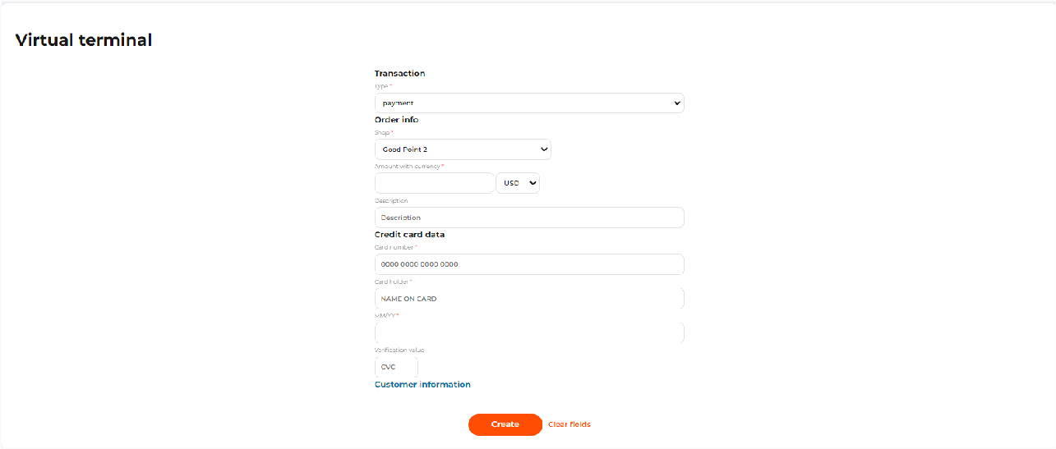
A MOTO form for a single transaction

Make mass payouts
See the file format in File for loading mass payout parameters.The service supports mass payouts to clients using the uploaded file with a list of parameters for payouts.

To make the mass payouts, follow the steps below:
- On the MOTO tab, in the Transaction section, choose Payout in the Type field.
- In the Order info section, select File.
- Fill in other fields as described in the table below.
- Select Create to launch mass payouts.

Table: Mass payout parameters

Parameter | Description | Notes
Shop* | A shop, on behalf of which the payments will be made.
File* | A field to upload a CSV file with a list of parameters for mass payout. | See the file format in File for loading mass payout parameters.
Email* | An email address to send notification of the results of transactions. | See the file format in Report file.

Parameter | Description | Notes
*required
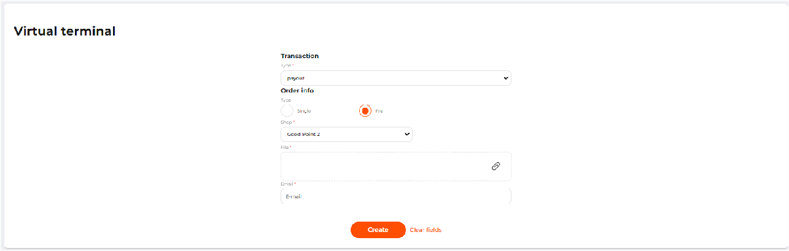
A MOTO form for a mass payout

After a successful file upload, the next message will be displayed:
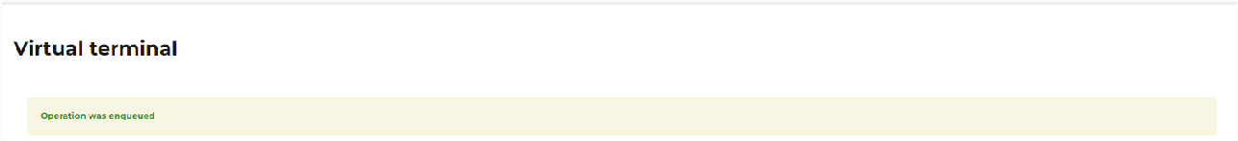

Besides, the system sends out a report on the payouts to the specified email. See the description of the file format in Report file.

File for loading mass payout parameters

Requirements to file:
- File format: *.csv.
- The maximum number of payouts per file is 1000.
- The file must be unique within the shop (the second attempt to make a mass payout for the same file will be rejected).
- Each row in the file must be unique.
- Mandatory parameters (headers):
  - amount - cost in minimal currency units, e.g. $32.45 must be sent as 3245.
  - сurrency - currency in ISO-4217 format, e.g. USD.
  - number - the recipient’s card number.
  - description - the short payout description. Max length: 255 chars.
- Only parameters (headers) published in the API description are allowed.

 Ask your Account Manager for a full list of parameters for your shop.

- The first row of the file must contain the headers, separated by (|). Their sequence can be any. For example:

amount|currency|number|description

- The rows of the file must match the headers and the contents of the row must be separated by (|):

amount|currency|number|description 100|USD|4200000000000000|description_text 200|USD|4012000000003101|description_text

Report file
- File format: *.csv.
- The first row of the file has headers with a separator (|). Each subsequent row corresponds to a separate payout.
- The order of the rows in the report is the same as the order of the rows in the uploaded file.
- The report file includes all the source parameters of payouts from the file for uploading and the reporting parameters of the performed transaction.

Report example:

request_status|transaction_uid|transaction_status|message|rrn|amount|currency|number| description|tracking_id|test
valid|10328-00ea89b8b5|successful|Payout was approved|123456789102|100|USD|420000 xxxx 0000|description_text|my_tracking_id_1|true
valid|10331-056b43604b|failed|Payout was declined|123456789105|100|USD|220138 xxxx 0021|description_text|my_tracking_id_2|true
valid|10332-18a4eaf0ad|failed|Payout was declined|123456789105|300|USD|220138 xxxx 0021|description_text|my_tracking_id_3|true

Report parameters:
- request_status - possible values are valid / invalid. The invalid status means that an error occurred in building a request to send to the gateway, or a response was not received from the gateway.
- transaction_uid - transaction ID in the system.
- transaction_status - status of the processed transaction:
  - successful - transaction was successfully processed.
  - failed - transaction was processed, and was declined by the gateway.
  - incomplete - transaction is not completed and additional merchant's actions are required.
  - expired - transaction processing time is expired.
- message - processing result message.
- rrn - bank transaction number.
- amount - cost in minimal currency units, e.g. $32.45 must be sent as 3245.

- currency - currency in ISO-4217 format, e.g. USD.
- number - the card number. The 4 digits are replaced with a mask XXXX.
- description - the short payout description.
- tracking_id - arbitrary identification number of the payment. If the parameter was not specified in the uploaded file, then it will be generated automatically.
- test - true or false. The transaction will be a test one if it is true. If the parameter was not specified in the uploaded file, then it will be specified automatically to false.

Google Pay
The service allows you to accept payments via Google Pay™.

If you used integration via payment widget, to enable payment acceptance via Google Pay, contact your Account manager.

Apple Pay
Apple Pay allows merchants to accept payments from customers who use cards linked to Apple Wallets.

There are 2 ways to work with Apple Pay:
- Enable Apple Pay under your own certificates. In this case, you get the certificates and upload them to the system.
- Enable Apple Pay under the provider’s certificates, i.e. use the certificates of your payment service provider.

In any way, you should abide by the Apple Pay terms of use:
  - You need an account in the Apple Developer program to register an individual Merchant ID (for simplified integration, please check the Merchant ID with your manager).
  - You can't use Apple Pay to pay for tobacco products, replicas, adult products, purchase virtual currency, or to top up wallets.
  - Apple Pay does not replace In-App Purchase in mobile apps.
  - Please follow the Apple guidelines if you are self-hosted on the web and for a mobile app https://developer.apple.com/apple-pay/Apple-Pay-Identity-Guidelines.pdf.
  - To use Apple Pay for charitable donations, please register on the Benevity portal https:// causes.benevity.org/causes/claim-cause-search.

Enable Apple Pay under your own certificates
If you have an account and a paid developer account in the Apple Pay Developer program https://developer.apple.com/, you can get Apple Pay Merchant and Apple Pay Processing certificates and upload them to the system.

To upload the certificates, follow the steps below:
- Go to the Apple Pay tab.
- Click Edit.
- In the window that opens, indicate your Apple Pay Merchant ID.

- Click Download a merchant certificate signing request, and download the CSR files that you will use to sign your certificates on the Apple side.
- Upload Apple Pay Merchant certificate and Apple Pay Processing certificate.
- Click Apply to save your changes.
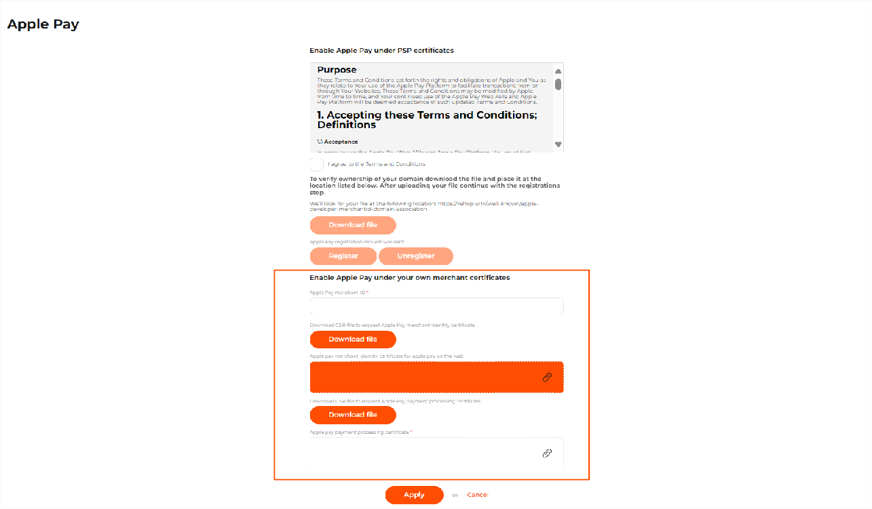
A form to enable Apple Pay under own certificates

Enable Apple Pay under your provider's certificates
Your payment service provider can provide their own certificates for Apple Pay.

To connect to Apple Pay under the provider’s certificates, please follow these steps:
- Go to the Apple Pay tab.
- Click Edit.
- Agree to the terms of the user agreement.
- Download the apple-developer-merchantid-domain-association domain verification file from the system.
- Place the downloaded file on your sites following the specified path: https:// <shop url>/.well-known/apple-developer-merchantid-domain-association , but instead of <shop url> please enter the URL of your shop.
- Select the shops that you want to connect Apple Pay to.
- Click Register. After that, your registration request will be sent to the Account manager.
- Click Apply.

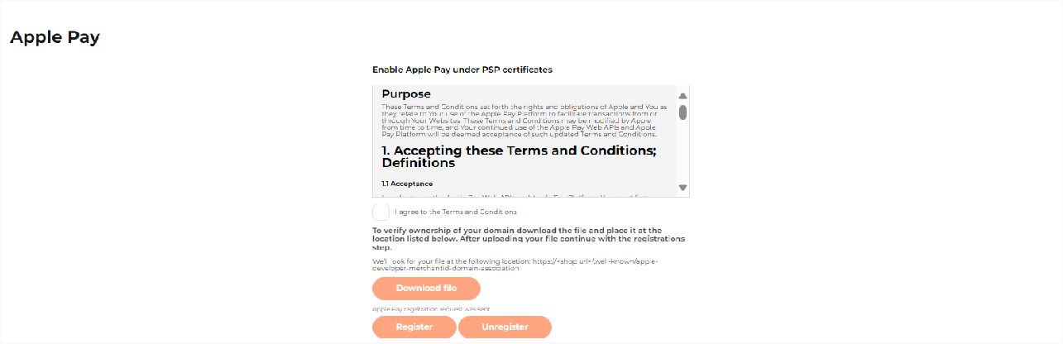
A form to enable Apple Pay under the provider’s certificates

After your Account manager confirms your registration, you will see the Apple Pay button.

Possible reasons for registration error
- Site without SSL. Make sure that all shop sites that you want to connect Apple Pay to have SSL enabled and are accessible without errors via https://<shop_url>
- The site host differs from the data in the system. For example, the site in the beGateway system is registered as https://example.com, but in reality, the site works at https:// www.example.com and when entering the https://example.com redirects to https:// www.example.com. Accordingly, Apple cannot download the verification file.

Transaction analysis and management
The system supports various types of transactions, including both the main types of financial transactions that lead to the movement of funds, and additional transactions used to obtain information, tokenize or encrypt data.

The system user interface displays the following types of transactions, as listed in the table below.

Table: Transaction types reported in the user back office

Transaction type | Description
Payment | Used for debiting funds for single-step payments.
Authorization | Blocking funds for a two-stage payment.
Capture | Debiting the previously blocked funds for two-step payments.
Void | Cancelling the previous blocking of the funds.
Credit | A payment to the client.
Refund | A full or partial refund of the previously debited amount.
Reversal | A cancellation of a completed payment with a refund of the entire amount to the payer's card.
Chargeback | A bank initiated Chargeback. As a rule, a chargeback occurs if the merchant refused to refund the payer, but the Bank decided that the merchant is obliged to return the money to the client (for example, for an unproven service).
Checkup | Performs full verification of bank details, including Limits and 3-D Secure, but without a transaction to the bank.
Fraud Advice | A transaction for collecting fines for a Chargeback.
Payout | A payout of funds from the account to the client's card.
P2P | A transfer of funds from card to card between private persons.
Each transaction has a status displayed in the system as an icon described in the table below.

Table: Transaction statuses

Icon | Status | Status description

 | Successful | Payment was made successfully.
 | Failed | Payment failed.
 | Incomplet e | The transaction has started, most likely the customer was redirected to the 3-D Secure verification form, and the system is waiting for the customer to return.
 | Pending | The payment request was created successfully and is waiting for a payment notification. This status is usually used for alternative payment methods.
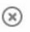 | Expired | The payment request has not been paid, and the payment period has expired, or a new payment request has been created with the same order/invoice or contract number. This status is usually used for alternative payment methods.
 | Deleted | The payment request was deleted by the merchant.
 | Suspicious | An additional status. Assigned when the transaction didn’t pass the check against the Smart Routing rule with Review action.
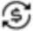 | Converted | An additional status. A transaction was converted to another currency via the Converter service, if it is activated.

Find a transaction
To find a transaction processed by a payment gateway of the merchant’s shop, go to the Orders tab page.

On the page that opens, the display area consists of a search and filter panel, a list of processed transactions in table form, and a pagination navigation panel.

To search for a transaction, follow the steps below:
- Specify transaction search parameters as described in the table below.
- If you want to search for test transactions, activate the Test transactions checkbox.
- Click Find.
- For a new search, click Clear fields and follow the steps again.

To search for a transaction, you must enter all or part of the data in the appropriate fields and use the search filters.

Table: Search and filter parameters

Parameter | Description
Search by transaction data
Transaction UID | A transaction ID in the system.
Tracking ID | A tracking ID assigned to a transaction in your order system. If multiple tracking_id values were sent in the request, the search can be performed by any of  them.
Payment description | A payment order or billing description indicated for a transaction.
Bank ID | An ID assigned to a transaction by the processor or an acquirer.
Amount | An amount of a processed transaction.
Currency | The amount value will be applied to the search results in the specified currency.
RRN | A Retrieval Reference Number, a transaction number assigned by an acquirer.
Transaction type | A transaction type.  A search across transactions of all types is set as default.  For more information on transaction types, see Transaction analysis and management.
Status | A transaction status.  A search across transactions of any status is set as default.  For more information on transaction types, see Transaction analysis and management.
Recurring type | The recurring type of the transaction. Possible values:  Not recurring transaction; Recurring transaction; Initial recurring transaction; d_moto
Payment method | A name or select a payment method used to make a transaction.  A search across all payment methods is set as default.

Parameter | Description
Processor account number | Account number specified for processing the transaction in the system of the alternative payment method provider.
Shop | A name, Shop ID or select a shop from the list of all shops registered in the system.
Search by bank card data
Card BIN | A card BIN, the first 6 digits of a card number.
1234 | The last 4 digits of a card number.
Card Mask | A card mask consisting of BIN+ xxxx+ last 4 digits.
Cardholder* | A name of the cardholder.
Select a country of the issuing bank | A search by name or select a country of a card issuer.
Credit card token | The token of the card. The search by token is enabled for the transactions processed after February 2025.
Search by client data*
Client email* | Customer’s email address indicated upon making a payment.
First or/and last name* | Customer’s name indicated upon making a payment.
Client phone* | Customer’s phone indicated upon making a payment.
Client IP* | IP address of a customer used upon making a payment.
Search by date
From | The start date and time of the transaction search period.  By default, the From field is set to the current day, 00:00:00 AM.
To | The end date and time of the transaction search period.  By default, a search result lists all transactions processed by the system up to the moment.

Parameter | Description
Date range on trx | The date type by which search results should be reset. Possible values:  Creation date: search date is set to the time of transaction request (by default);  Paid date: search date is set to the time of actual transaction completion.
Time Zone | The time zone to specify the Creation and Paid date. By default, set to the time zone of your payment service provider.
Search for a fraud operation
Check result | A result of the Smart Routing service check:  Review only: displays transactions to which Review action was applied as a result of the Smart Routing check;  Reject only: displays transactions to which Reject action was applied as a result of the Smart Routing check.
Fields marked with * are not displayed for the users without the Personal data access
permission.
After the search is finished, the system shows a list of transactions with a summary. One page shows the latest 15 transactions that match the search criteria. To view other transactions, use the pagination navigation panel at the bottom of the page.

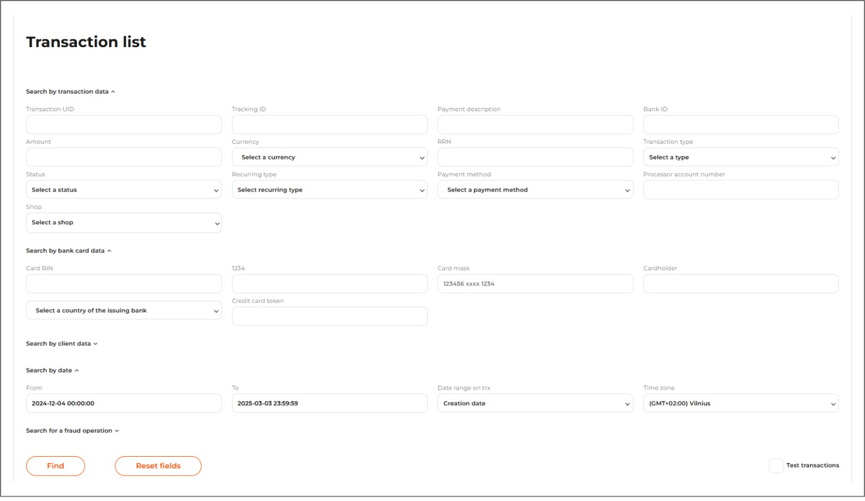
Orders tab for the users with the Personal data access permission

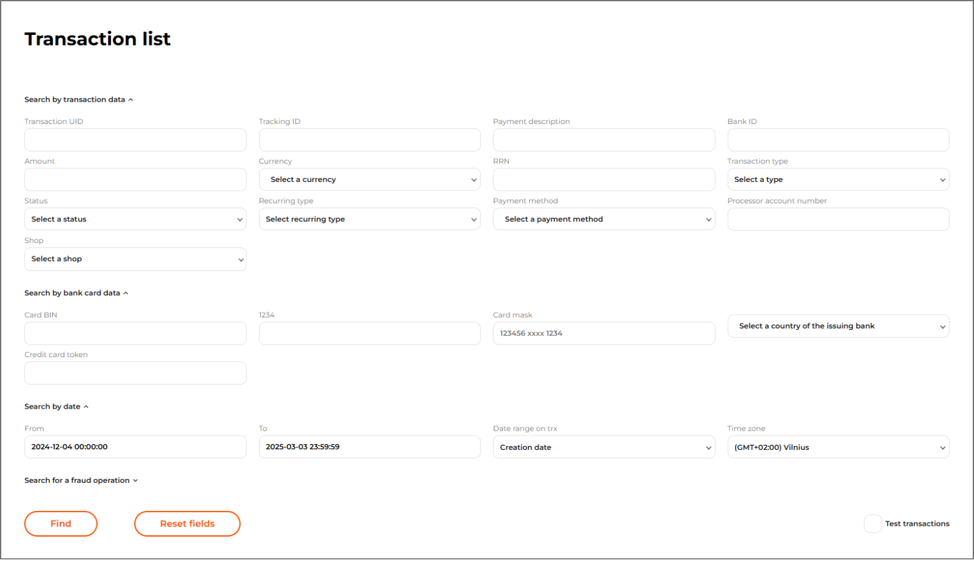
Orders tab for the users without the Personal data access permission

Please note, a card mask is a credit card numbers in the “BIN******last 4 digits” format.
The system detects only the first 6 digits of a card BIN. Therefore, all card numbers matching first 6 and last 4 digits are shown as a search result.

View transaction summary
To view a summary of transactions processed by a payment gateway of the merchant’s shop, go to the Orders tab page.

On the page that opens, the display area consists of a search and filter panel, a list of processed transactions in table form, and a pagination navigation panel. If you need to search for a transaction, see Find a transaction.

For each transaction, the table shows:
- Transaction status;
- Transaction:
  - Transaction type;
  - Amount and currency;
  - Transaction ID as a link to the transaction details page;
  - Tracking ID is the merchant's transaction ID;
- Date:
  - Creation date as a date and time when the transaction was created at;
  - Payment date as a date and time when the transaction was paid at, if available;
- Payment method:
For card payments:
  - A payment brand;
  - A card issuer’s country;
  - A card mask;
  - A card expiration date;
  - Number counter of successful transactions with the card (highlighted in green), unsuccessful transactions with the card (highlighted in black), Refunds for the card (highlighted in orange), and Chargebacks (highlighted in red);
  - A cardholder's name, as entered during a payment; For alternative payments:
  - A payment brand;
  - Additional information depending on the payment method;
- Customer:
  - A billing name;
  - An email address;
  - Number counter of successful transactions with this email address (highlighted in green), unsuccessful transactions with this email address (highlighted in black), Refunds this email address (highlighted in orange), and Chargebacks this email address (highlighted in red);
  - Customer’s address and country;
  - An IP address;
  - Number counter of successful transactions with this IP address (highlighted in green), unsuccessful transactions with this IP address (highlighted in black),

- Shop:

Refunds with this IP address (highlighted in orange), and Chargebacks with this IP address (highlighted in red);
Shop name as a link to the shop settings page. Shop status (Enabled or Disabled).
The e-mail address of the shop’s contact person.

One page shows the latest 15 processed transactions. To view other transactions, use the pagination navigation panel at the bottom of the page.

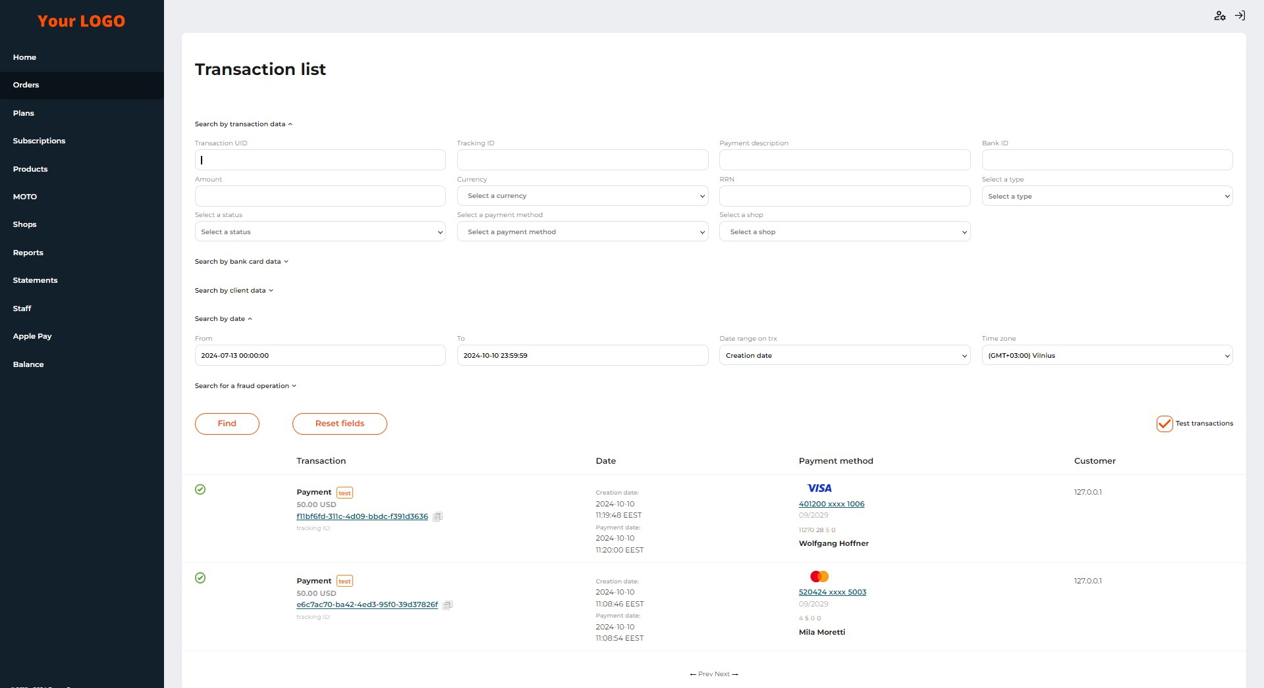
The ‘Orders’ tab with a list of transactions

The system also allows you to quickly go to the list of all transactions that were made using one card (by card mask). To view such transactions, click on the value of the card mask in the transaction line.

 Please note, a card mask is a credit card numbers in the “BIN******last 4 digits” format.
The system detects only the first 6 digits of a card BIN. Therefore, all card numbers matching first 6 and last 4 digits are shown as a search result.

View transaction details
To see detailed information about a transaction, follow these steps:

- Go to the Orders tab page.
- Select the required transaction. If necessary, use Find a transaction.
- Click on the transaction ID (UID) as a link.

Detailed information about the required transaction consists of the following sections:
  - Order description: a description of an order added for a payment;
  - Payment method:
For card payments:
    - A payment brand;
    - A card issuer’s country;
    - A card mask;
    - A card expiration date;
    - A cardholder's name, as entered during a payment;
For alternative payments:
    - A payment brand;
    - Additional information depending on the payment method;
  - Customer:
    - A billing name;
    - An email address;
    - Customer’s address and country;
    - An IP address;

  - Shop:

Shop name as a link to the shop settings page. Shop status (Enabled or Disabled).
The e-mail address of the shop’s contact person.

  - Merchant:
    - The merchant’s contact person;
    - The merchant’s activation status;
  - Transaction details:
    - A transaction type;
    - An amount and a currency of a processed transaction;
    - A transaction status;
    - A transaction UID;
    - A message, as additional processing information;
    - An authorization code;
    - A bank ID, as an ID assigned to a transaction by the processor or an acquirer;
    - A Retrieval Reference Number (RRN);
    - A bank’s response code;
    - A conversion rate applicable to convert a transaction amount from a payment currency to a currency supported by the payment gateway, for converted payments;
    - A converted amount, for converted payments;
    - A tracking ID, as an identifier assigned by the merchant;
    - A transaction creation date;
    - A transaction payment date, for successful transactions;
    - A conversion date, as a date of a conversion rate, applied to the transaction;
    - The Rec Recurring transaction flag for initial and recurring transactions for payments by saved cards.
  - Anti-fraud verifications:
    - A verification status, as described in the table below;
    - Rule conditions.

Table: Statuses of the Smart Routing verification service checks

Icon | Description
 | A transaction matches a rule with the Reject action type. A transaction is declined. A rule description is highlighted in red.
 | A transaction matches a rule with the Review action type. The system sends out a notification to an email set in the merchant account settings. A rule description is highlighted in orange. A transaction is marked with the following graphical element:
 | A transaction matches neither a rule with the Reject action type, nor a rule with the Review action type. The check is passed successfully.
 | The check was not applicable because of insufficient date.
Next to the customer's card number, email address, and IP address, there are placed buttons for managing data in the white and black lists. For more information, see Black and white lists of customers' data.
  - SmartRouting service results:
    - Rules — results of transaction check against the rules of action type.
    - Whitelisted data — results of transaction parameter check against whitelists. If the transaction parameter value is in the whitelist, the parameter name is displayed.
    - Blacklisted data — results of transaction parameter check against blacklists. If the transaction parameter value is in the blacklist, the parameter name is displayed.

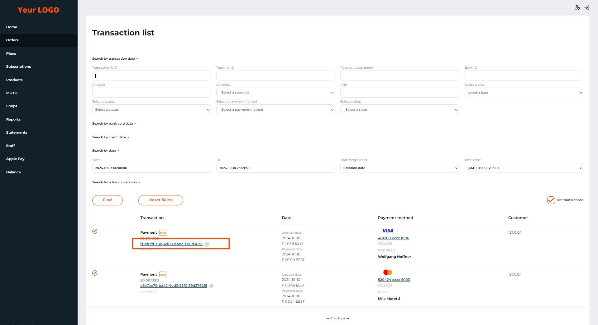
The transaction UID on the ‘Orders’ tab

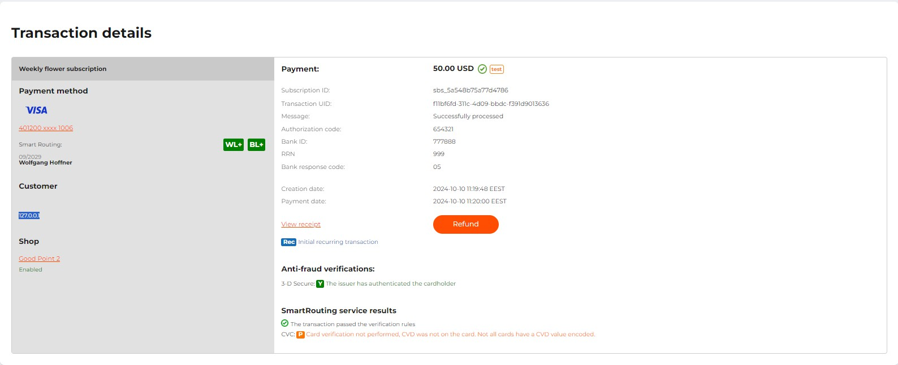
The ‘Transaction details' page

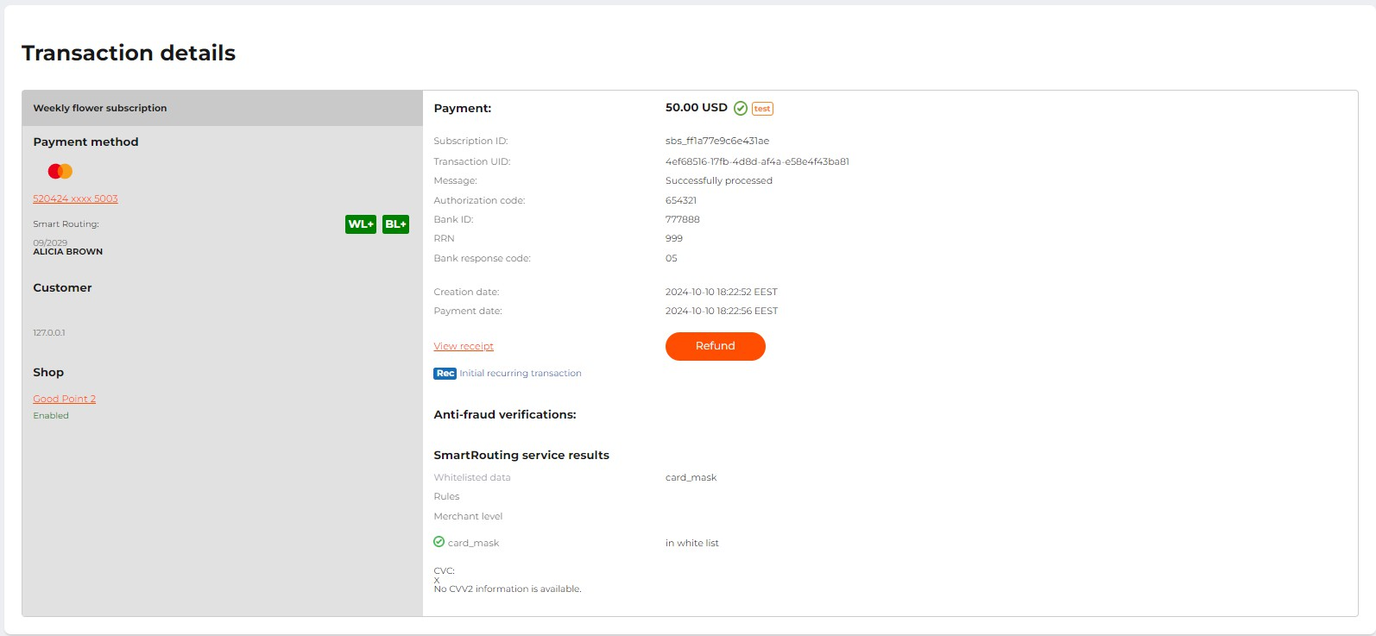
Transaction details: according to SmartRouting service results, the transaction card mask is in the whitelist

If a transaction is linked to another transaction, such as Void and Authorization, or Capture and Authorization, such transactions will also be displayed when viewing each related transaction as part of a transaction, i.e. one transaction is enough to view all related transactions.

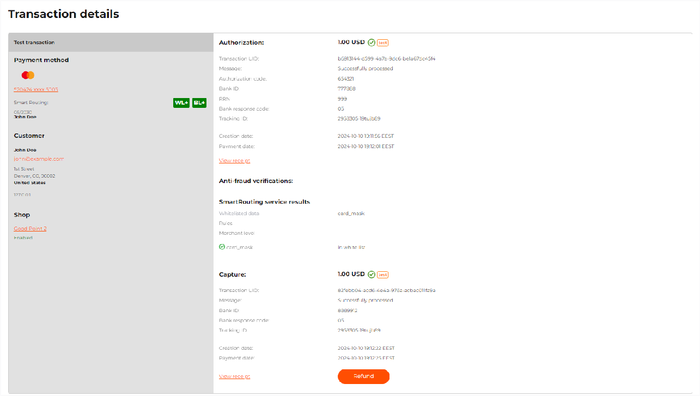
The ‘Transactions details’ page for related transactions

The transaction details page also gives access to additional options. To get a transaction receipt in the PDF format, click View receipt.
The following functions are available for transactions of the Authorization type:
- Void: to initiate a transaction of the Void type for the full amount of the Authorization transaction;
- Capture: to initiate a transaction of the Capture type. For the Capture transaction, you must specify the Capture amount, that does not exceed the amount of Authorization.

For Payment and Capture transactions, Refunds are available. Click Refund, and the system will initiate a full refund to the customer's card.

Manage black and white lists of customers' data
The system supports a preliminary check of incoming transactions based on black and white lists of customers' data.

Black lists contain the data of customers from whom merchants do not want to accept payments for some reason, for example, due to potential fraud. A payment whose parameters have values of the black list is automatically rejected before the system passes it to the acquirer for further verification and processing. Though, the black list doesn’t prevent processing refunds.

White lists are used for data of trusted customers. When processing payments, if a payment parameter has a value of the white list, the system sends the transaction to the specified gateway.

You can add the data of the card mask used for payment to the black and white lists, if needed. The payment service provider may also add the buyer's email address and IP address details to a list for you.

To manage the lists, use the buttons described in the table below.

Table: Buttons to manage values in the black and white lists

Button | Description
 | A value is not added to the white list. Click to add it to the white list if it is not yet included in the black list.
 | A value is not added to the black list. Click to add it to the black list if it is not yet included in the white list.
 | A value was added to the white list. Click to remove it from the white list.
 | A value was added to the black list. Click to remove it from the black list.

To add a card mask to the list, follow the steps below:
- Go to the Orders tab page.
- Find a payment with customer details. Use the description of the search in Find a transaction.
- Click on the transaction UID.
- Use the buttons to add or delete card number data from the black and white lists.

Please note, a card mask is a credit card numbers in the “BIN******last 4 digits” format.
The system detects only the first 6 digits of a card BIN. Therefore, all card numbers matching first 6 and last 4 digits are added to the white list.

Dаshboard
The merchants have access to the Dashboard tab that visualizes transaction data on the 4 charts. The merchants can enable the access to the tab for their staff members by selecting the corresponding checkbox when editing/adding a staff member. By default, the charts display data for the last 3 days. Currently, the following charts are available:
- Conversion graph
- Decline codes
- Successful transactions
- Daily history

All filter fields are available for all the four charts on clicking the gear icon. The filter fields correspond to the relevant fields in the reports. The possible values for the fields may differ depending on the chart.

Parameter | Description
From | The start date of the reporting period. By default, set to current day minus 2 days. The maximum reporting period is 90 days.
To | The end date of the reporting period. Not earlier than a date in the From field. By default, set to current date. The maximum reporting period is 90 days.
Date range on trx | Transaction date and time. Possible values:  Creation date: date and time when a transaction is created in the system.  Paid date: date and time when a transaction is processed by an acquirer or a provider.  Settlement date: date and time when a transaction is cleared (transaction amount is settled to a merchant account).  Updated date (available only for the Decline codes chart): the day when the transaction was updated.

Parameter | Description
Time zone | Relevant time zone for the dashboard. After the time zone is specified, the system recalculates the transaction dates and time to the selected time zone.
Recurring type | A transaction recurring type. Possible values:  All: to see transactions of all statuses. Set by default.  Not recurring transaction: to see transactions that are not recurrent.  Recurring transaction: to see all recurring transactions. Initial recurring transaction: to see all initial payments for recurring transactions.
Shop | The name of the shop Possible values:  None: the system will generate a dashboard on transactions of all registered merchant shops. Set by default.  All: the system will generate a dashboard on transactions of all registered merchant shops.  [Merchant shop name]: The system will generate a dashboard on transactions initiated through the selected shop.
Payment method | Payment method used to make a transaction. Possible values:  None: the system will generate a dashboard on transactions initiated by all payment methods. Set by default.  All: the system will generate a dashboard on transactions initiated by all payment methods.  Payment method name or brand: the system will generate a dashboard on transactions initiated by this payment method depending on the value in the Shop field.
Country | Country of a customer. Possible values:  None: the system will generate a dashboard on transactions initiated from all countries. Set by default.  All: the system will generate a dashboard on transactions initiated from all countries.  EU: The system will generate a dashboard on transactions initiated from all countries of the European Union.  Non-EU: The system will generate a dashboard on transactions initiated from all countries outside the European Union.
Currency | Transaction currency. Possible values:  All: the system will generate a dashboard with data grouped by each currency. Set by default. Available only for Conversion graph and Decline codes charts.  Currency out of the list: the system will generate a dashboard on transactions processed in this currency.

Parameter | Description
Transaction type | Transaction type.  The value of this filtering field can be changed only for Decline codes chart. For the other charts the Transaction type field is autofilled with the following values:  Conversion graph: payments and authorization. Successful transactions: payment and capture. Daily history: payment and capture.
Status | Transaction status.  This field is disabled for editing and is set to the following values: Conversion graph: All  Decline codes: Failed  Successful transactions: Successful Daily history: All

Conversion graph
This chart shows the graphs for the following metrics:
- Successful transactions
- Failed transactions
- Conversion

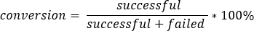

Clicking on the corresponding metric names in the chart legend hides/displays the corresponding graphs. Hovering over a point on the graph displays a tooltip with the corresponding values.

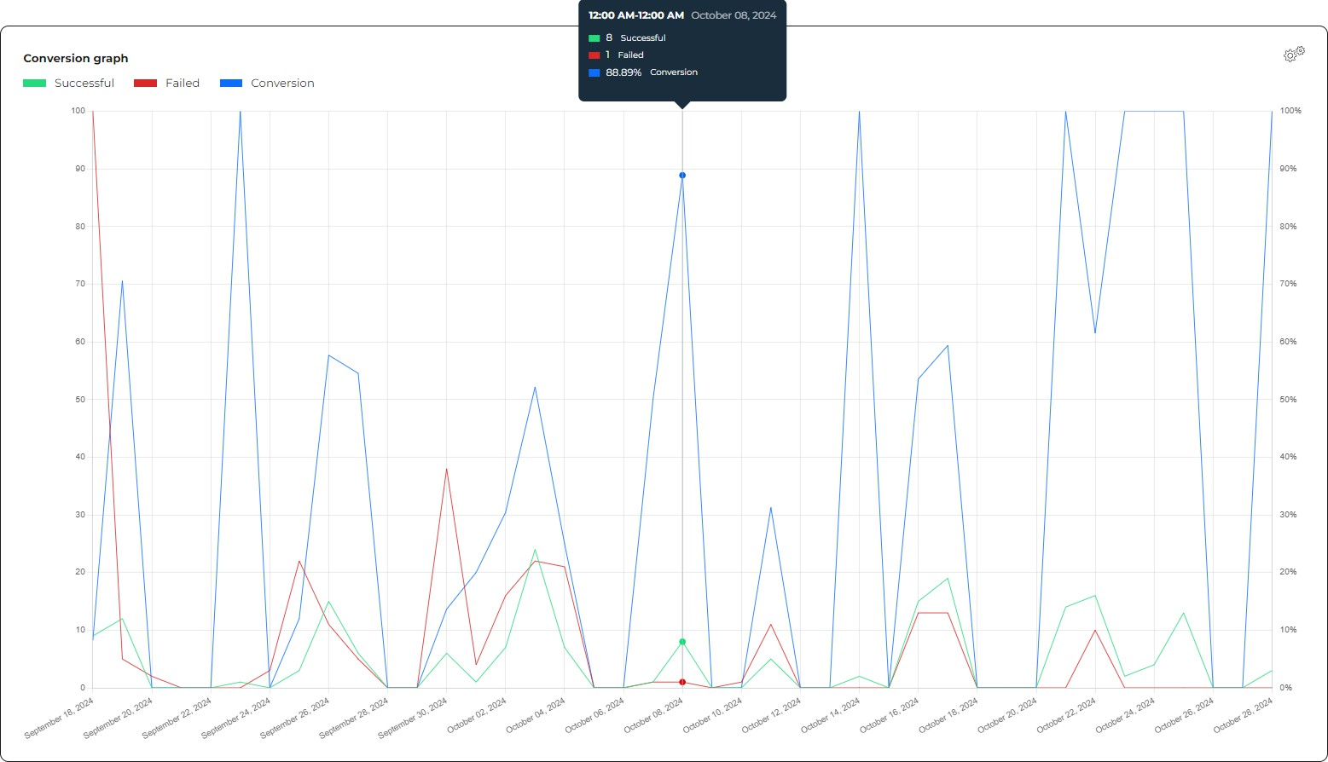

Decline Codes
This chart displays the decline codes that were received during the selected period, their error codes and their share in the overall number of failed transactions. Clicking the info icon next to the decline code or hovering over the corresponding area on the chart displays the text of the decline code.

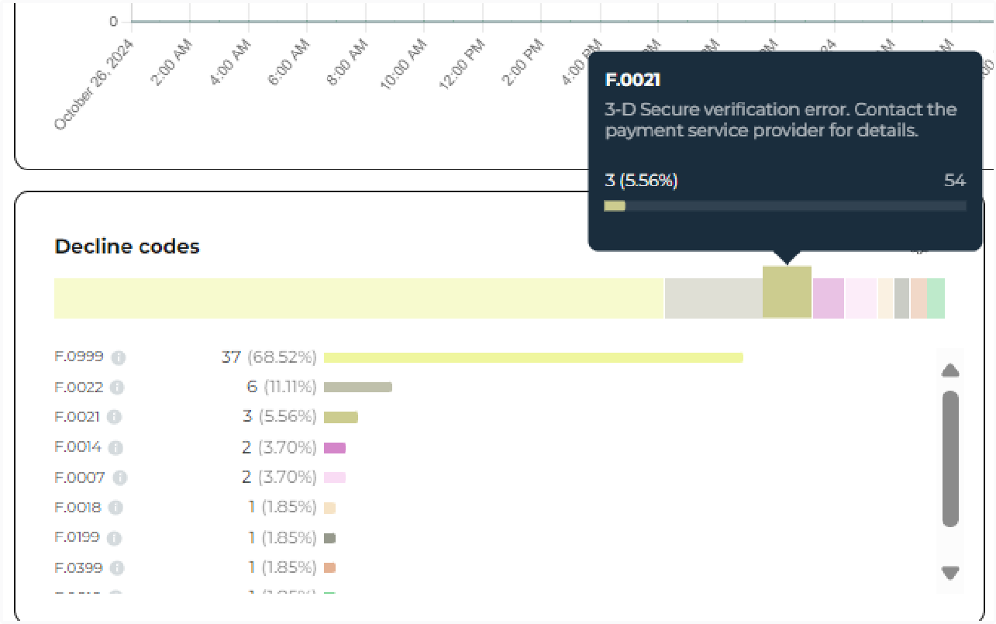

Successful transactions
This chart displays the number and the sum of successful transactions on each day/hour in the selected period. The overall successful transactions amount and their number for the period are displayed in the chart legend. Hovering over a particular column displays the actual metric values for the selected day/hour. Clicking on the metric name in the chart legend hides/displays the corresponding columns/graph.

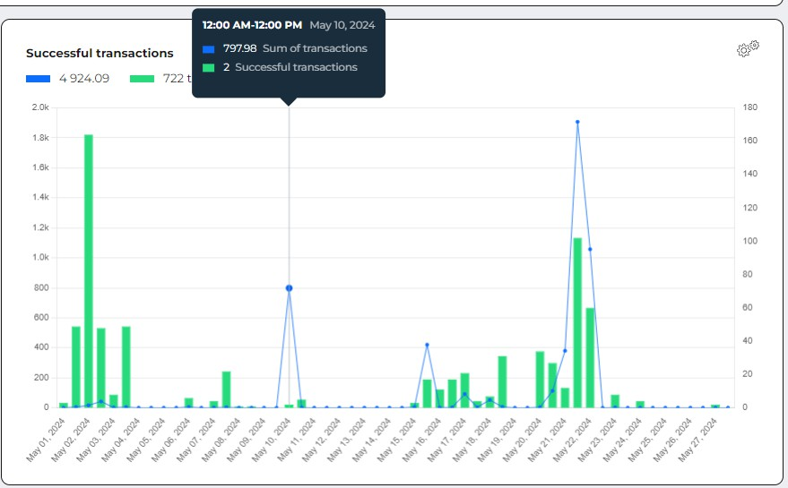

Daily history
This table shows the sum and the number of successful and failed transactions over the selected period grouped by days. Each line corresponds to a particular day in the selected period and additionally contains the conversion rate value (the share of the number of successful transactions in the overall number of transactions) and the conversion rate chart.
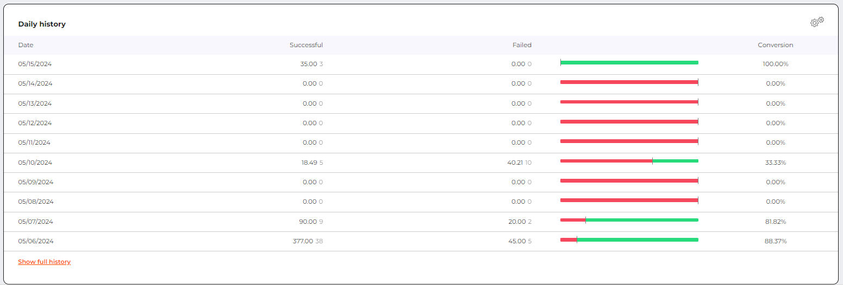

Financial information

Payment statistics
The system provides statistical data on the most important indicators for your business:
- The total income received;
- Ratio between successful and unsuccessful payments and authorizations;
- The amount and number of Captures;
- The amount and number of Refunds and Reversals;
- The amount and number of Chargebacks.
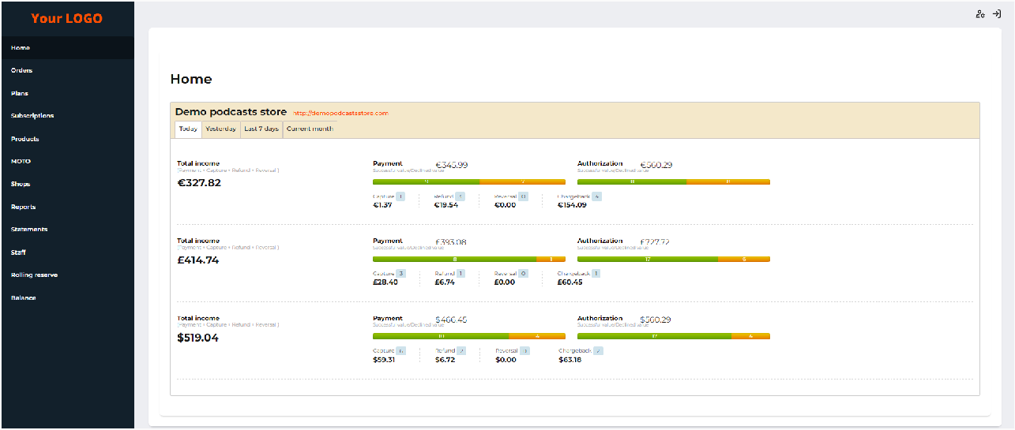
The ‘Dashboard’ tab

The statistical report is presented for each currency separately. It allows you to view statistics for real (not test) transactions for today, yesterday, for the last 7 days, for the current month.

To view the statistics, go to the Home tab page in your back office.

In case of no real payments, the tab page will show information about how to integrate with the system.

Report on transactions
In addition to quick payment statistics you can get on the Home page, the system provides a more flexible report with the ability to export the result.

These reports include financial payments, i.e. payments that were sent to the bank and received the final status. Test payments, payments that were rejected due to incorrect data, and incomplete payments are not included in these reports.

View a report
To get and view the report, follow the steps below:
- Go to the Reports tab page.
- Set the parameters for generating the report as described in the table below.
- Click Run report.

Table: Report parameters, filters, and possible values

Parameter | Description
From | A start date of the reporting period. Current date is set by default.
To | An end date of the reporting period, not earlier than a date in the From field. Current date is set by default.
Group by | Data grouping order. Possible values:  Interactive: Data are not aggregated automatically. Interactive mode will be activated. Set by default.  Daily: Data are aggregated automatically by each day of the reporting period.  Monthly: Data are aggregated automatically by each month of the reporting period.
Date range on trx | Transaction date and time. Possible values:  Creation date: Date and time when a transaction is created in the system.  Paid date: Date and time when a transaction is processed by an acquirer or a processor. Set by default.  Settlement date: Date and time when a transaction is cleared (transaction amount is settled to a merchant account).
Time zone | A relevant time zone for the report.  After the time zone is specified, the system resets the transaction dates and time to the selected time zone.
Recurring type | A type of recurring transaction. Possible values:  All: to show the report of transactions of all types. Set by default. Not recurring transaction: to show the report of non-recurring transactions only.  Recurring transaction: to show the report of recurring transactions only.  Initial recurring transaction: to show the report of initial recurring transactions only.

Parameter | Description
Shop | A name of the merchant’s shop.  Possible values:  None: The system will generate a consolidated report on transactions of all registered merchant shops. Set by default.  All: The system will generate a report with data grouped by each shop.  Merchant shop name out of the list: The system will generate a report on transactions initiated through this shop.
Payment method | A payment method used to make a transaction. Possible values:  None: The system will generate a consolidated report on transactions initiated by all payment methods. Set by default. All: The system will generate a report with data grouped by each payment method.  Payment method name or brand out of the list: The system will generate a report on transactions initiated by this payment method.
Provider | Provider, the source of the payment token used for the transaction. Possible values:  None: the system will generate a consolidated report on all transactions processed with or without using a payment token from Apple Pay, Google Pay or Samsung Pay token providers. All: the system will generate a report on transactions grouped by the payment token provider.  Not applicable: the system will generate a report on the transactions that were processed without the tokens of the payment token providers.  ( credit_card.token_provider = null )  {Payment token provider name}: the system will generate a report on transactions processed using the token of the specified payment token providers (Apple Pay, Google Pay or Samsung Pay).
Country | A country of a customer. Possible values:  None: The system will generate a consolidated report on transactions initiated from all countries. Set by default.  All: The system will generate a report with data grouped by each country.  EU: The system will generate a report with data grouped by each country of the European Union.  Non-EU: The system will generate a report with data grouped by each country outside the European Union.

Parameter | Description
Currency | A transaction currency. Possible values:  All: The system will generate a report with data grouped by each currency. Set by default.  Currency out of the list: The system will generate a report on transactions processed in this currency.  All in EUR: The system will generate a report with amounts converted to EUR at the exchange rate set by Open Exchange. All in USD: The system will generate a report with amounts converted to USD at the exchange rate set by Open Exchange. All in GBP: The system will generate a report with amounts converted to GBP at the exchange rate set by Open Exchange. All in RUB: The system will generate a report with amounts converted to RUB at the exchange rate set by Open Exchange.
Transaction type | A transaction type as defined by the system. Possible values:  All: The system will generate a report with data grouped by each transaction type.  Transaction type out of the list: The system will generate a report on transactions of the selected transaction type.
Status | A transaction status as defined by the system. Possible values:  All: The system will generate a report with data grouped by each transaction status. Set by default.  Successful: The system will generate a report only on successful transactions.  Failed: The system will generate a report only on failed transactions.
If you select the Enable multiselect checkbox, you can set several values in the Shop and Transaction type fields. The report will include data matching all selected values. The field hint indicates how many values are chosen.

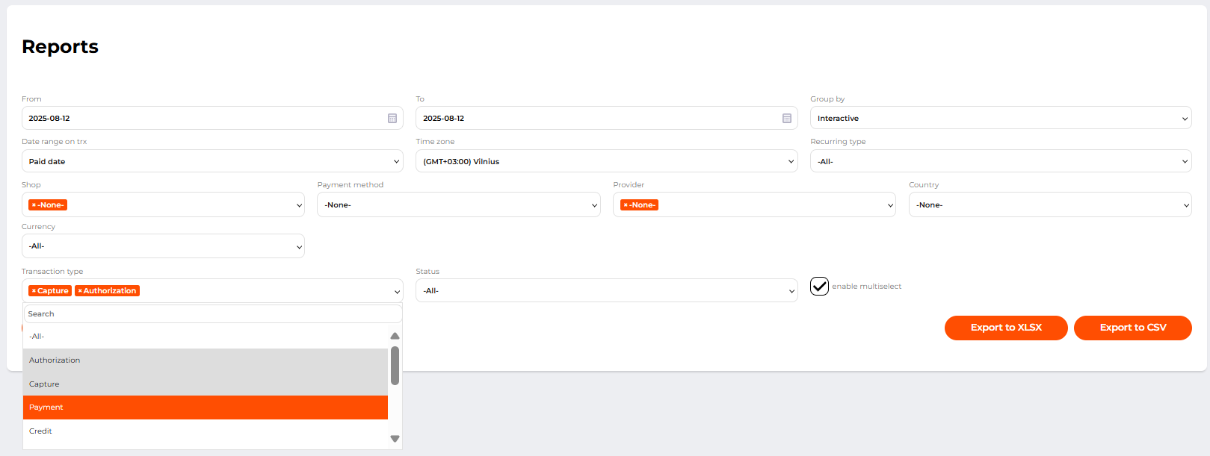
Multiselect on the ‘Reports’ tab

After generating a report on the specified parameters, the system will display information in a table form indicating the number and total amount of transactions corresponding to the parameters. For a report grouped by days or months, a period will also be specified.
If the Group by parameter is set to Interactive, the report is displayed in the interactive mode. The interactive mode allows users:
- to search a value across the report outcome instantly in the Search field;
- to see the overall number of reported transactions in the Total field at the bottom of the report table;
- to sort the data instantly on one or on a few columns of the report table.

To sort the output data on a column, use the arrows next to the column name to arrange the data in ascending or descending order. Multi-column ordering can be activated by Shift + click on columns. The clicked column is added as a secondary, tertiary, etc ordering column.

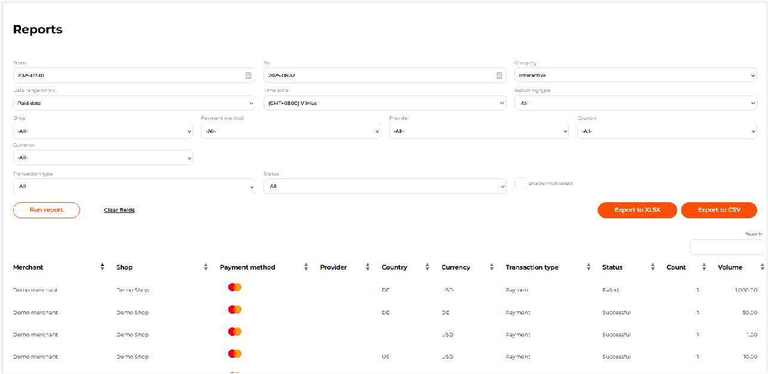
The report in the interactive mode
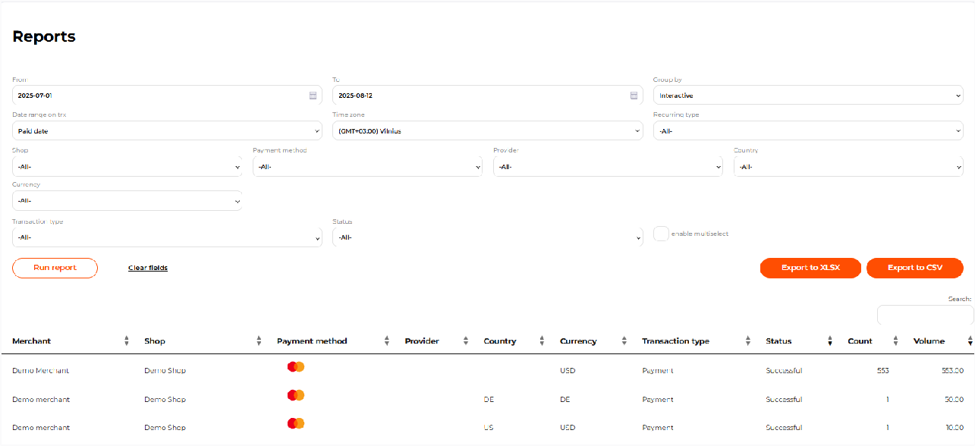
The report sorted by the Transaction type and Status columns

Instant search and sorting outcome can not be saved and exported.

Export a transaction report
To receive a payment report by email, follow these steps:
- Go to the Reports tab page.
- Set the parameters for generating the report, as described in View a report.
- Click Export to XLSX or Export to CSV to download the report in the desired format.

- Enter an email address to which a link to download the report will be sent.
- Activate the Include transactions checkbox to get a report with detailed information about each transaction, if required.
- Click Send.

The report export file in Excel format can contain no more than 1.048.576 transactions. If the number of the reported transactions is more, please specify the parameters.

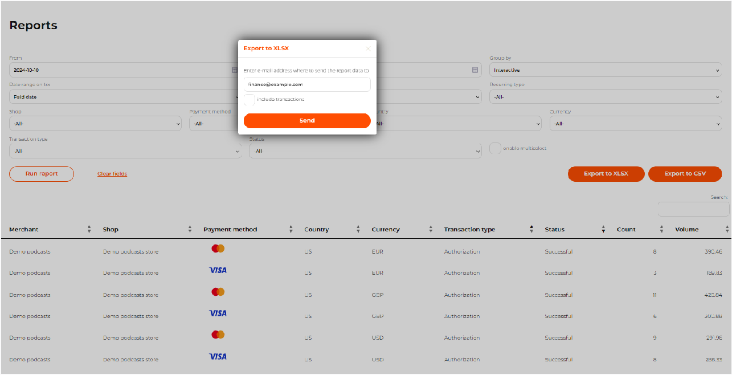
The Report export window

Selecting the checkbox Include transactions displays a list of available columns for the additional tab in the report:

Column name | Description
transactions uid | Transaction UID.
order id | Order identifier.
tracking id | Transaction’s identifier in the merchant system.
status | Transaction status.
description | Order description.
amount | Transaction amount in base currency units.

Column name | Description
currency | Transaction currency.
discount rate | Transaction fee, in %.
transaction rate | Fixed transaction fee in the transaction currency, in base currency units.
transaction fee | Total amount of transaction fees, in base currency units.
settled amount | Amount to be paid to the merchant after deducting commissions, in base currency units.
transaction type | Transaction type.
created at | Date and time when the transaction was created.
paid at | Date and time when the transaction was completed.
settled at | Date and time when the transaction amount is credited to the merchant's account by the acquirer.
expired at | Date and time when the order expires, time until which the customer can complete the transaction
message | Transaction processing result message.
shop id | Shop identifier in the PSP system.
shop | Shop name in the PSP system.
bank acquirer | Gateway/bank name.
gateway note | Gateway note field value in the gateway settings.
business category | Business category of the shop.
bank id | Transaction identifier in the acquirer’s system.
first name | Customer’s first name.
last name | Customer’s last name.
address | Customer’s billing address.
country | Customer’s billing country.
city | Customer’s billing city.
postal code | Customer's billing ZIP or postal code.

Column name | Description
state | Customer’s billing state or region.
phone | Customer’s phone.
ip | Customer’s IP address.
e-mail | Customer’s email.
brand | Card brand.
merchant id | Merchant identifier in the PSP system.
merchant country | Merchant’s country.
merchant company | Merchant’s company name.
amount after conversion | Transaction amount after conversion.
currency after conversion | Transaction currency after conversion.
gateway id | Gateway identifier in the PSP system.
recurring type | Recurring type of the transaction.
payment method fields | Adds payment method fields to the report.
connection type | Connection type field value in the gateway settings.
response code | Transaction processing result code.
initial amount | Initial transaction amount.
surcharge amount | Applied surcharge amount.
exchange rate | Exchange rate used for the transaction conversion.
agent fields | Adds agent fields to the report.
settled amount after conversion | Converted transaction amount to be paid to the merchant, in base currency units.
transaction fee after conversion | Total amount of the transaction fees after conversion, in base currency units.

The following items are not available for the users without the Personal data access permission: First name, Last name, Address, City, Postal code, State, Phone, IP, E-mail, Card holder.

As soon as the report is generated, a link to the report is sent to the indicated email address. The link expires in 72 hours. To access the report, the user must be logged into the system using the same account as the one used for exporting the report.

The Excel file that you’ll get can contain one or several sheets with data in columns. The report view and the number of sheets in the file depend on what report parameters are set and whether the detailed information on transactions was requested.

The first sheet contains the overall basic information on the transactions.
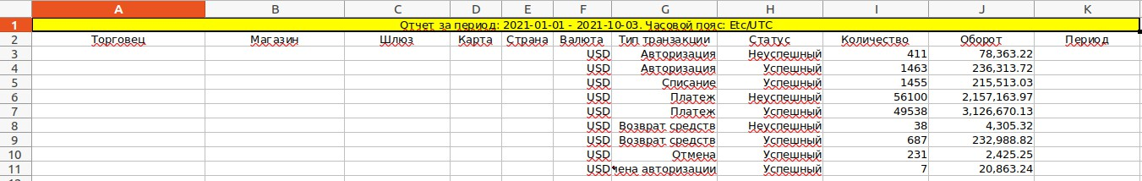
The Summary sheet of an exported report in the XLSX format (a part of the sheet shown)

The second and following sheets contain detailed information on card transactions and operations initiated by alternative payment methods. Transactions processed by alternative payment methods with counters are listed on a separate sheet.
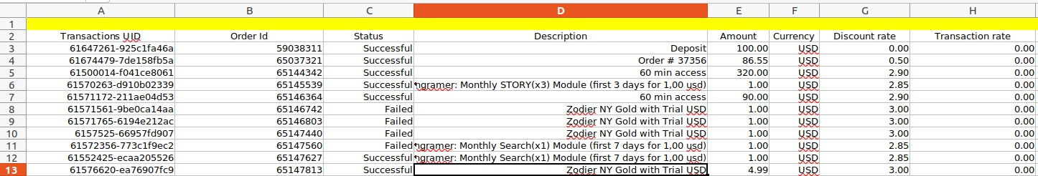
The Card transaction sheet of an exported report in the CSV format (a part of the sheet shown)

If you click Export to CSV, you will get a link to your email address. Click the link and save the ZIP archive. The archive contains:
- description.txt - a file with the reporting period and time zone description;
- totals.csv - a file with the overall information on the reported transactions;
- one or several files in the {payment method}.csv format - a file with data on transactions initiated by a payment method which is indicated in the file name.
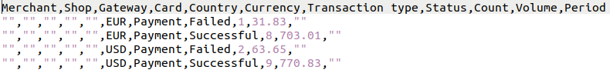
Example of the “totals.csv” file (part)

Merchant balance. Version 2

The merchant balance. Version 2
The Balance page displays the merchant balance and the balances of their shops. The balances are grouped by transaction currencies.

To access the new version of Balance, go to {backoffice_url}/merchant/balances
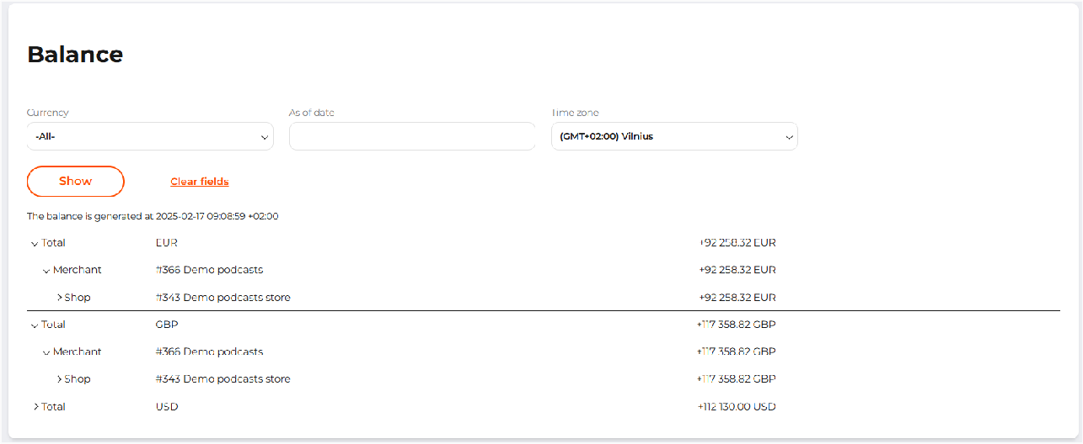

To display balance of the merchant, fill in the fields according to the table below. To display shop balances expand Total row and then expand Merchant row.

Table: Merchant balance parameters

Field | Description
Currency | The list of currencies.  Select -All- to display balances for all currencies available on the gateways.
As of date | Date and time picker. By default, the current date and time are applied.
Time zone | By default, the PSP timezone is set.

